HW3_all.R (Weekend and Weekday)

Jennifer

Tue Apr 04 12:08:58 2017

setwd("C:/Users/Jennifer/Documents/ADM/HW 3")  
bakery<-read.csv("bakery_binary.csv")  
str(bakery)

## 'data.frame': 1000 obs. of 51 variables:  
## $ Chocolate.Cake : int 0 0 1 0 0 0 0 0 1 1 ...  
## $ Lemon.Cake : int 0 0 0 0 0 0 0 0 0 0 ...  
## $ Casino.Cake : int 0 0 0 1 1 0 0 0 0 1 ...  
## $ Opera.Cake : int 0 1 0 0 0 0 1 1 0 0 ...  
## $ Strawberry.Cake : int 0 0 1 0 0 0 0 0 0 0 ...  
## $ Truffle.Cake : int 0 0 0 0 0 0 0 0 0 0 ...  
## $ Chocolate.Eclair : int 0 0 0 1 0 0 0 1 0 0 ...  
## $ Coffee.Eclair : int 0 0 0 0 0 0 0 0 0 0 ...  
## $ Vanilla.Eclair : int 0 0 0 0 0 0 0 0 0 0 ...  
## $ Napoleon.Cake : int 0 0 1 0 0 1 0 0 0 0 ...  
## $ Almond.Tart : int 0 0 0 0 1 0 0 0 0 0 ...  
## $ Apple.Pie : int 0 0 0 0 0 0 0 0 0 0 ...  
## $ Apple.Tart : int 0 0 0 0 0 0 0 0 0 0 ...  
## $ Apricot.Tart : int 0 0 0 0 0 0 0 1 0 0 ...  
## $ Berry.Tart : int 0 0 0 0 0 0 0 0 0 0 ...  
## $ Blackberry.Tart : int 1 0 0 0 0 0 0 0 0 0 ...  
## $ Blueberry.Tart : int 0 0 0 0 0 0 0 0 0 0 ...  
## $ Chocolate.Tart : int 0 0 0 0 0 0 0 0 0 0 ...  
## $ Cherry.Tart : int 0 1 0 0 0 0 0 0 0 0 ...  
## $ Lemon.Tart : int 0 0 0 0 0 0 0 0 0 0 ...  
## $ Pecan.Tart : int 0 0 0 0 0 0 0 0 0 0 ...  
## $ Ganache.Cookie : int 0 0 0 0 0 0 0 0 0 0 ...  
## $ Gongolais.Cookie : int 0 0 0 1 1 0 0 0 0 0 ...  
## $ Raspberry.Cookie : int 0 0 0 0 0 0 0 0 0 0 ...  
## $ Lemon.Cookie : int 0 0 0 0 0 0 0 0 0 0 ...  
## $ Chocolate.Meringue : int 0 0 0 0 0 0 0 0 0 0 ...  
## $ Vanilla.Meringue : int 0 0 0 0 0 0 0 0 0 0 ...  
## $ Marzipan.Cookie : int 0 0 0 0 0 1 0 0 0 0 ...  
## $ Tuile.Cookie : int 0 0 0 0 0 1 0 0 0 0 ...  
## $ Walnut.Cookie : int 0 0 0 0 0 0 1 0 0 0 ...  
## $ Almond.Croissant : int 0 0 1 0 0 0 0 0 0 0 ...  
## $ Apple.Croissant : int 0 0 0 0 1 0 0 0 0 0 ...  
## $ Apricot.Croissant : int 0 0 0 1 0 0 0 0 0 0 ...  
## $ Cheese.Croissant : int 0 0 1 0 1 0 0 0 0 0 ...  
## $ Chocolate.Croissant: int 1 0 0 0 0 0 0 0 0 0 ...  
## $ Apricot.Danish : int 0 1 0 0 0 0 0 0 0 0 ...  
## $ Apple.Danish : int 0 0 0 0 0 0 0 0 0 0 ...  
## $ Almond.Twist : int 0 0 0 0 0 0 0 0 0 0 ...  
## $ Almond.Bear.Claw : int 0 0 0 0 0 0 0 0 0 0 ...  
## $ Blueberry.Danish : int 0 0 0 0 0 0 0 0 0 0 ...  
## $ Lemon.Lemonade : int 0 0 0 0 0 0 0 0 0 0 ...  
## $ Raspberry.Lemonade : int 0 0 0 0 0 0 0 0 0 0 ...  
## $ Orange.Juice : int 0 0 0 0 0 0 0 0 0 0 ...  
## $ Green.Tea : int 0 0 0 0 0 0 0 0 0 0 ...  
## $ Bottled.Water : int 0 0 0 0 0 0 1 0 0 0 ...  
## $ Hot.Coffee : int 0 0 0 0 0 1 0 0 0 0 ...  
## $ Chocolate.Coffee : int 0 0 0 0 1 0 0 0 0 1 ...  
## $ Vanilla.Frappuccino: int 1 0 0 0 0 0 0 0 0 0 ...  
## $ Cherry.Soda : int 0 0 0 0 0 0 0 0 0 0 ...  
## $ Single.Espresso : int 0 0 0 0 0 0 0 0 0 0 ...  
## $ Weekend : int 0 0 1 1 0 0 0 0 0 0 ...

summary(bakery)

## Chocolate.Cake Lemon.Cake Casino.Cake Opera.Cake   
## Min. :0.000 Min. :0.000 Min. :0.000 Min. :0.000   
## 1st Qu.:0.000 1st Qu.:0.000 1st Qu.:0.000 1st Qu.:0.000   
## Median :0.000 Median :0.000 Median :0.000 Median :0.000   
## Mean :0.084 Mean :0.085 Mean :0.072 Mean :0.078   
## 3rd Qu.:0.000 3rd Qu.:0.000 3rd Qu.:0.000 3rd Qu.:0.000   
## Max. :1.000 Max. :1.000 Max. :1.000 Max. :1.000   
## Strawberry.Cake Truffle.Cake Chocolate.Eclair Coffee.Eclair   
## Min. :0.000 Min. :0.000 Min. :0.000 Min. :0.000   
## 1st Qu.:0.000 1st Qu.:0.000 1st Qu.:0.000 1st Qu.:0.000   
## Median :0.000 Median :0.000 Median :0.000 Median :0.000   
## Mean :0.091 Mean :0.103 Mean :0.034 Mean :0.093   
## 3rd Qu.:0.000 3rd Qu.:0.000 3rd Qu.:0.000 3rd Qu.:0.000   
## Max. :1.000 Max. :1.000 Max. :1.000 Max. :1.000   
## Vanilla.Eclair Napoleon.Cake Almond.Tart Apple.Pie   
## Min. :0.000 Min. :0.00 Min. :0.000 Min. :0.000   
## 1st Qu.:0.000 1st Qu.:0.00 1st Qu.:0.000 1st Qu.:0.000   
## Median :0.000 Median :0.00 Median :0.000 Median :0.000   
## Mean :0.037 Mean :0.09 Mean :0.041 Mean :0.068   
## 3rd Qu.:0.000 3rd Qu.:0.00 3rd Qu.:0.000 3rd Qu.:0.000   
## Max. :1.000 Max. :1.00 Max. :1.000 Max. :1.000   
## Apple.Tart Apricot.Tart Berry.Tart Blackberry.Tart  
## Min. :0.000 Min. :0.000 Min. :0.000 Min. :0.000   
## 1st Qu.:0.000 1st Qu.:0.000 1st Qu.:0.000 1st Qu.:0.000   
## Median :0.000 Median :0.000 Median :0.000 Median :0.000   
## Mean :0.079 Mean :0.056 Mean :0.095 Mean :0.073   
## 3rd Qu.:0.000 3rd Qu.:0.000 3rd Qu.:0.000 3rd Qu.:0.000   
## Max. :1.000 Max. :1.000 Max. :1.000 Max. :1.000   
## Blueberry.Tart Chocolate.Tart Cherry.Tart Lemon.Tart   
## Min. :0.000 Min. :0.000 Min. :0.000 Min. :0.000   
## 1st Qu.:0.000 1st Qu.:0.000 1st Qu.:0.000 1st Qu.:0.000   
## Median :0.000 Median :0.000 Median :0.000 Median :0.000   
## Mean :0.081 Mean :0.051 Mean :0.084 Mean :0.076   
## 3rd Qu.:0.000 3rd Qu.:0.000 3rd Qu.:0.000 3rd Qu.:0.000   
## Max. :1.000 Max. :1.000 Max. :1.000 Max. :1.000   
## Pecan.Tart Ganache.Cookie Gongolais.Cookie Raspberry.Cookie  
## Min. :0.00 Min. :0.000 Min. :0.000 Min. :0.000   
## 1st Qu.:0.00 1st Qu.:0.000 1st Qu.:0.000 1st Qu.:0.000   
## Median :0.00 Median :0.000 Median :0.000 Median :0.000   
## Mean :0.04 Mean :0.044 Mean :0.108 Mean :0.082   
## 3rd Qu.:0.00 3rd Qu.:0.000 3rd Qu.:0.000 3rd Qu.:0.000   
## Max. :1.00 Max. :1.000 Max. :1.000 Max. :1.000   
## Lemon.Cookie Chocolate.Meringue Vanilla.Meringue Marzipan.Cookie  
## Min. :0.000 Min. :0.000 Min. :0.000 Min. :0.00   
## 1st Qu.:0.000 1st Qu.:0.000 1st Qu.:0.000 1st Qu.:0.00   
## Median :0.000 Median :0.000 Median :0.000 Median :0.00   
## Mean :0.066 Mean :0.038 Mean :0.047 Mean :0.09   
## 3rd Qu.:0.000 3rd Qu.:0.000 3rd Qu.:0.000 3rd Qu.:0.00   
## Max. :1.000 Max. :1.000 Max. :1.000 Max. :1.00   
## Tuile.Cookie Walnut.Cookie Almond.Croissant Apple.Croissant  
## Min. :0.000 Min. :0.000 Min. :0.000 Min. :0.000   
## 1st Qu.:0.000 1st Qu.:0.000 1st Qu.:0.000 1st Qu.:0.000   
## Median :0.000 Median :0.000 Median :0.000 Median :0.000   
## Mean :0.102 Mean :0.061 Mean :0.049 Mean :0.091   
## 3rd Qu.:0.000 3rd Qu.:0.000 3rd Qu.:0.000 3rd Qu.:0.000   
## Max. :1.000 Max. :1.000 Max. :1.000 Max. :1.000   
## Apricot.Croissant Cheese.Croissant Chocolate.Croissant Apricot.Danish   
## Min. :0.000 Min. :0.000 Min. :0.000 Min. :0.000   
## 1st Qu.:0.000 1st Qu.:0.000 1st Qu.:0.000 1st Qu.:0.000   
## Median :0.000 Median :0.000 Median :0.000 Median :0.000   
## Mean :0.076 Mean :0.078 Mean :0.042 Mean :0.075   
## 3rd Qu.:0.000 3rd Qu.:0.000 3rd Qu.:0.000 3rd Qu.:0.000   
## Max. :1.000 Max. :1.000 Max. :1.000 Max. :1.000   
## Apple.Danish Almond.Twist Almond.Bear.Claw Blueberry.Danish  
## Min. :0.000 Min. :0.000 Min. :0.000 Min. :0.000   
## 1st Qu.:0.000 1st Qu.:0.000 1st Qu.:0.000 1st Qu.:0.000   
## Median :0.000 Median :0.000 Median :0.000 Median :0.000   
## Mean :0.084 Mean :0.065 Mean :0.026 Mean :0.055   
## 3rd Qu.:0.000 3rd Qu.:0.000 3rd Qu.:0.000 3rd Qu.:0.000   
## Max. :1.000 Max. :1.000 Max. :1.000 Max. :1.000   
## Lemon.Lemonade Raspberry.Lemonade Orange.Juice Green.Tea   
## Min. :0.000 Min. :0.000 Min. :0.000 Min. :0.000   
## 1st Qu.:0.000 1st Qu.:0.000 1st Qu.:0.000 1st Qu.:0.000   
## Median :0.000 Median :0.000 Median :0.000 Median :0.000   
## Mean :0.066 Mean :0.072 Mean :0.082 Mean :0.062   
## 3rd Qu.:0.000 3rd Qu.:0.000 3rd Qu.:0.000 3rd Qu.:0.000   
## Max. :1.000 Max. :1.000 Max. :1.000 Max. :1.000   
## Bottled.Water Hot.Coffee Chocolate.Coffee Vanilla.Frappuccino  
## Min. :0.000 Min. :0.000 Min. :0.000 Min. :0.000   
## 1st Qu.:0.000 1st Qu.:0.000 1st Qu.:0.000 1st Qu.:0.000   
## Median :0.000 Median :0.000 Median :0.000 Median :0.000   
## Mean :0.077 Mean :0.094 Mean :0.085 Mean :0.074   
## 3rd Qu.:0.000 3rd Qu.:0.000 3rd Qu.:0.000 3rd Qu.:0.000   
## Max. :1.000 Max. :1.000 Max. :1.000 Max. :1.000   
## Cherry.Soda Single.Espresso Weekend   
## Min. :0.000 Min. :0.000 Min. :0.000   
## 1st Qu.:0.000 1st Qu.:0.000 1st Qu.:0.000   
## Median :0.000 Median :0.000 Median :0.000   
## Mean :0.077 Mean :0.059 Mean :0.315   
## 3rd Qu.:0.000 3rd Qu.:0.000 3rd Qu.:1.000   
## Max. :1.000 Max. :1.000 Max. :1.000

bakery<-bakery[,c(1:6, 8:10, 12:26, 28:34, 36:38, 40:51)]   
str(bakery)

## 'data.frame': 1000 obs. of 46 variables:  
## $ Chocolate.Cake : int 0 0 1 0 0 0 0 0 1 1 ...  
## $ Lemon.Cake : int 0 0 0 0 0 0 0 0 0 0 ...  
## $ Casino.Cake : int 0 0 0 1 1 0 0 0 0 1 ...  
## $ Opera.Cake : int 0 1 0 0 0 0 1 1 0 0 ...  
## $ Strawberry.Cake : int 0 0 1 0 0 0 0 0 0 0 ...  
## $ Truffle.Cake : int 0 0 0 0 0 0 0 0 0 0 ...  
## $ Coffee.Eclair : int 0 0 0 0 0 0 0 0 0 0 ...  
## $ Vanilla.Eclair : int 0 0 0 0 0 0 0 0 0 0 ...  
## $ Napoleon.Cake : int 0 0 1 0 0 1 0 0 0 0 ...  
## $ Apple.Pie : int 0 0 0 0 0 0 0 0 0 0 ...  
## $ Apple.Tart : int 0 0 0 0 0 0 0 0 0 0 ...  
## $ Apricot.Tart : int 0 0 0 0 0 0 0 1 0 0 ...  
## $ Berry.Tart : int 0 0 0 0 0 0 0 0 0 0 ...  
## $ Blackberry.Tart : int 1 0 0 0 0 0 0 0 0 0 ...  
## $ Blueberry.Tart : int 0 0 0 0 0 0 0 0 0 0 ...  
## $ Chocolate.Tart : int 0 0 0 0 0 0 0 0 0 0 ...  
## $ Cherry.Tart : int 0 1 0 0 0 0 0 0 0 0 ...  
## $ Lemon.Tart : int 0 0 0 0 0 0 0 0 0 0 ...  
## $ Pecan.Tart : int 0 0 0 0 0 0 0 0 0 0 ...  
## $ Ganache.Cookie : int 0 0 0 0 0 0 0 0 0 0 ...  
## $ Gongolais.Cookie : int 0 0 0 1 1 0 0 0 0 0 ...  
## $ Raspberry.Cookie : int 0 0 0 0 0 0 0 0 0 0 ...  
## $ Lemon.Cookie : int 0 0 0 0 0 0 0 0 0 0 ...  
## $ Chocolate.Meringue : int 0 0 0 0 0 0 0 0 0 0 ...  
## $ Marzipan.Cookie : int 0 0 0 0 0 1 0 0 0 0 ...  
## $ Tuile.Cookie : int 0 0 0 0 0 1 0 0 0 0 ...  
## $ Walnut.Cookie : int 0 0 0 0 0 0 1 0 0 0 ...  
## $ Almond.Croissant : int 0 0 1 0 0 0 0 0 0 0 ...  
## $ Apple.Croissant : int 0 0 0 0 1 0 0 0 0 0 ...  
## $ Apricot.Croissant : int 0 0 0 1 0 0 0 0 0 0 ...  
## $ Cheese.Croissant : int 0 0 1 0 1 0 0 0 0 0 ...  
## $ Apricot.Danish : int 0 1 0 0 0 0 0 0 0 0 ...  
## $ Apple.Danish : int 0 0 0 0 0 0 0 0 0 0 ...  
## $ Almond.Twist : int 0 0 0 0 0 0 0 0 0 0 ...  
## $ Blueberry.Danish : int 0 0 0 0 0 0 0 0 0 0 ...  
## $ Lemon.Lemonade : int 0 0 0 0 0 0 0 0 0 0 ...  
## $ Raspberry.Lemonade : int 0 0 0 0 0 0 0 0 0 0 ...  
## $ Orange.Juice : int 0 0 0 0 0 0 0 0 0 0 ...  
## $ Green.Tea : int 0 0 0 0 0 0 0 0 0 0 ...  
## $ Bottled.Water : int 0 0 0 0 0 0 1 0 0 0 ...  
## $ Hot.Coffee : int 0 0 0 0 0 1 0 0 0 0 ...  
## $ Chocolate.Coffee : int 0 0 0 0 1 0 0 0 0 1 ...  
## $ Vanilla.Frappuccino: int 1 0 0 0 0 0 0 0 0 0 ...  
## $ Cherry.Soda : int 0 0 0 0 0 0 0 0 0 0 ...  
## $ Single.Espresso : int 0 0 0 0 0 0 0 0 0 0 ...  
## $ Weekend : int 0 0 1 1 0 0 0 0 0 0 ...

summary(bakery)

## Chocolate.Cake Lemon.Cake Casino.Cake Opera.Cake   
## Min. :0.000 Min. :0.000 Min. :0.000 Min. :0.000   
## 1st Qu.:0.000 1st Qu.:0.000 1st Qu.:0.000 1st Qu.:0.000   
## Median :0.000 Median :0.000 Median :0.000 Median :0.000   
## Mean :0.084 Mean :0.085 Mean :0.072 Mean :0.078   
## 3rd Qu.:0.000 3rd Qu.:0.000 3rd Qu.:0.000 3rd Qu.:0.000   
## Max. :1.000 Max. :1.000 Max. :1.000 Max. :1.000   
## Strawberry.Cake Truffle.Cake Coffee.Eclair Vanilla.Eclair   
## Min. :0.000 Min. :0.000 Min. :0.000 Min. :0.000   
## 1st Qu.:0.000 1st Qu.:0.000 1st Qu.:0.000 1st Qu.:0.000   
## Median :0.000 Median :0.000 Median :0.000 Median :0.000   
## Mean :0.091 Mean :0.103 Mean :0.093 Mean :0.037   
## 3rd Qu.:0.000 3rd Qu.:0.000 3rd Qu.:0.000 3rd Qu.:0.000   
## Max. :1.000 Max. :1.000 Max. :1.000 Max. :1.000   
## Napoleon.Cake Apple.Pie Apple.Tart Apricot.Tart   
## Min. :0.00 Min. :0.000 Min. :0.000 Min. :0.000   
## 1st Qu.:0.00 1st Qu.:0.000 1st Qu.:0.000 1st Qu.:0.000   
## Median :0.00 Median :0.000 Median :0.000 Median :0.000   
## Mean :0.09 Mean :0.068 Mean :0.079 Mean :0.056   
## 3rd Qu.:0.00 3rd Qu.:0.000 3rd Qu.:0.000 3rd Qu.:0.000   
## Max. :1.00 Max. :1.000 Max. :1.000 Max. :1.000   
## Berry.Tart Blackberry.Tart Blueberry.Tart Chocolate.Tart   
## Min. :0.000 Min. :0.000 Min. :0.000 Min. :0.000   
## 1st Qu.:0.000 1st Qu.:0.000 1st Qu.:0.000 1st Qu.:0.000   
## Median :0.000 Median :0.000 Median :0.000 Median :0.000   
## Mean :0.095 Mean :0.073 Mean :0.081 Mean :0.051   
## 3rd Qu.:0.000 3rd Qu.:0.000 3rd Qu.:0.000 3rd Qu.:0.000   
## Max. :1.000 Max. :1.000 Max. :1.000 Max. :1.000   
## Cherry.Tart Lemon.Tart Pecan.Tart Ganache.Cookie   
## Min. :0.000 Min. :0.000 Min. :0.00 Min. :0.000   
## 1st Qu.:0.000 1st Qu.:0.000 1st Qu.:0.00 1st Qu.:0.000   
## Median :0.000 Median :0.000 Median :0.00 Median :0.000   
## Mean :0.084 Mean :0.076 Mean :0.04 Mean :0.044   
## 3rd Qu.:0.000 3rd Qu.:0.000 3rd Qu.:0.00 3rd Qu.:0.000   
## Max. :1.000 Max. :1.000 Max. :1.00 Max. :1.000   
## Gongolais.Cookie Raspberry.Cookie Lemon.Cookie Chocolate.Meringue  
## Min. :0.000 Min. :0.000 Min. :0.000 Min. :0.000   
## 1st Qu.:0.000 1st Qu.:0.000 1st Qu.:0.000 1st Qu.:0.000   
## Median :0.000 Median :0.000 Median :0.000 Median :0.000   
## Mean :0.108 Mean :0.082 Mean :0.066 Mean :0.038   
## 3rd Qu.:0.000 3rd Qu.:0.000 3rd Qu.:0.000 3rd Qu.:0.000   
## Max. :1.000 Max. :1.000 Max. :1.000 Max. :1.000   
## Marzipan.Cookie Tuile.Cookie Walnut.Cookie Almond.Croissant  
## Min. :0.00 Min. :0.000 Min. :0.000 Min. :0.000   
## 1st Qu.:0.00 1st Qu.:0.000 1st Qu.:0.000 1st Qu.:0.000   
## Median :0.00 Median :0.000 Median :0.000 Median :0.000   
## Mean :0.09 Mean :0.102 Mean :0.061 Mean :0.049   
## 3rd Qu.:0.00 3rd Qu.:0.000 3rd Qu.:0.000 3rd Qu.:0.000   
## Max. :1.00 Max. :1.000 Max. :1.000 Max. :1.000   
## Apple.Croissant Apricot.Croissant Cheese.Croissant Apricot.Danish   
## Min. :0.000 Min. :0.000 Min. :0.000 Min. :0.000   
## 1st Qu.:0.000 1st Qu.:0.000 1st Qu.:0.000 1st Qu.:0.000   
## Median :0.000 Median :0.000 Median :0.000 Median :0.000   
## Mean :0.091 Mean :0.076 Mean :0.078 Mean :0.075   
## 3rd Qu.:0.000 3rd Qu.:0.000 3rd Qu.:0.000 3rd Qu.:0.000   
## Max. :1.000 Max. :1.000 Max. :1.000 Max. :1.000   
## Apple.Danish Almond.Twist Blueberry.Danish Lemon.Lemonade   
## Min. :0.000 Min. :0.000 Min. :0.000 Min. :0.000   
## 1st Qu.:0.000 1st Qu.:0.000 1st Qu.:0.000 1st Qu.:0.000   
## Median :0.000 Median :0.000 Median :0.000 Median :0.000   
## Mean :0.084 Mean :0.065 Mean :0.055 Mean :0.066   
## 3rd Qu.:0.000 3rd Qu.:0.000 3rd Qu.:0.000 3rd Qu.:0.000   
## Max. :1.000 Max. :1.000 Max. :1.000 Max. :1.000   
## Raspberry.Lemonade Orange.Juice Green.Tea Bottled.Water   
## Min. :0.000 Min. :0.000 Min. :0.000 Min. :0.000   
## 1st Qu.:0.000 1st Qu.:0.000 1st Qu.:0.000 1st Qu.:0.000   
## Median :0.000 Median :0.000 Median :0.000 Median :0.000   
## Mean :0.072 Mean :0.082 Mean :0.062 Mean :0.077   
## 3rd Qu.:0.000 3rd Qu.:0.000 3rd Qu.:0.000 3rd Qu.:0.000   
## Max. :1.000 Max. :1.000 Max. :1.000 Max. :1.000   
## Hot.Coffee Chocolate.Coffee Vanilla.Frappuccino Cherry.Soda   
## Min. :0.000 Min. :0.000 Min. :0.000 Min. :0.000   
## 1st Qu.:0.000 1st Qu.:0.000 1st Qu.:0.000 1st Qu.:0.000   
## Median :0.000 Median :0.000 Median :0.000 Median :0.000   
## Mean :0.094 Mean :0.085 Mean :0.074 Mean :0.077   
## 3rd Qu.:0.000 3rd Qu.:0.000 3rd Qu.:0.000 3rd Qu.:0.000   
## Max. :1.000 Max. :1.000 Max. :1.000 Max. :1.000   
## Single.Espresso Weekend   
## Min. :0.000 Min. :0.000   
## 1st Qu.:0.000 1st Qu.:0.000   
## Median :0.000 Median :0.000   
## Mean :0.059 Mean :0.315   
## 3rd Qu.:0.000 3rd Qu.:1.000   
## Max. :1.000 Max. :1.000

set.seed(123)  
bakerycluster4 <- kmeans(bakery, centers=4)   
bakerycluster4$size

## [1] 536 82 91 291

names(bakerycluster4)

## [1] "cluster" "centers" "totss" "withinss"   
## [5] "tot.withinss" "betweenss" "size" "iter"   
## [9] "ifault"

library(fpc)

## Warning: package 'fpc' was built under R version 3.3.3

plotcluster(bakery, bakerycluster4$cluster, main="k=4")

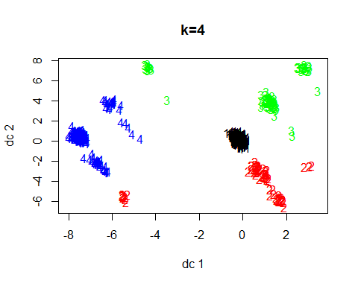

bakerycluster4$withinss

## [1] 1562.6493 211.3780 270.3736 888.8179

bakerycluster4$tot.withinss

## [1] 2933.219

bakerycluster4$betweenss

## [1] 368.2442

bakerycluster4$totss

## [1] 3301.463

set.seed(123)  
bakerycluster5 <- kmeans(bakery, centers=5)   
bakerycluster5$size

## [1] 118 104 103 131 544

plotcluster(bakery, bakerycluster5$cluster, main="k = 5")

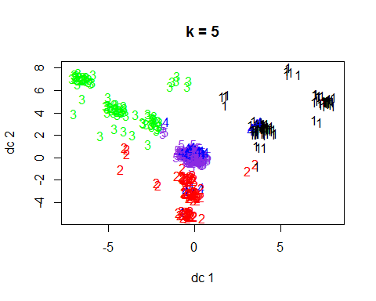

bakerycluster5$withinss

## [1] 325.4576 287.2308 302.0971 368.2595 1624.1985

bakerycluster5$tot.withinss

## [1] 2907.244

bakerycluster5$betweenss

## [1] 394.2194

bakerycluster5$totss

## [1] 3301.463

set.seed(123)  
bakerycluster6 <- kmeans(bakery, centers=6)   
bakerycluster6$size

## [1] 87 76 84 49 456 248

plotcluster(bakery, bakerycluster6$cluster, main="k = 6")

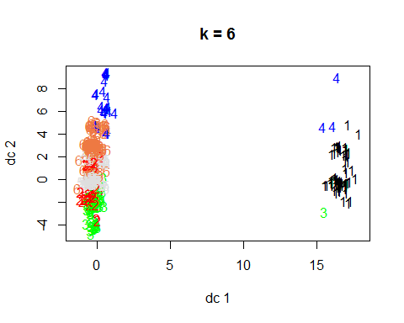

bakerycluster6$withinss

## [1] 205.81609 183.89474 238.72619 67.22449 1297.32675 750.71774

bakerycluster6$tot.withinss

## [1] 2743.706

bakerycluster6$betweenss

## [1] 557.757

bakerycluster6$totss

## [1] 3301.463

set.seed(123)  
bakerycluster7 <- kmeans(bakery, centers=7)   
bakerycluster7$size

## [1] 92 76 77 49 431 246 29

plotcluster(bakery, bakerycluster7$cluster, main="k = 7")

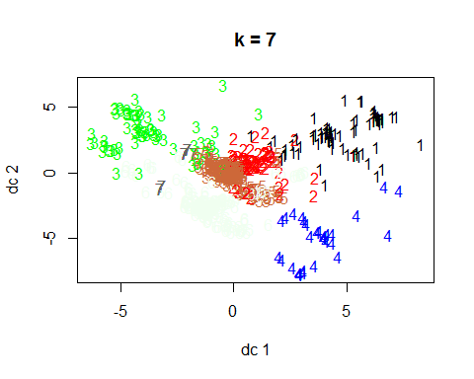

bakerycluster7$withinss

## [1] 234.50000 186.19737 203.27273 67.22449 1193.89327 732.45528  
## [7] 14.27586

bakerycluster7$tot.withinss

## [1] 2631.819

bakerycluster7$betweenss

## [1] 669.644

bakerycluster7$totss

## [1] 3301.463

set.seed(123)  
bakerycluster8 <- kmeans(bakery, centers=8)   
bakerycluster8$size

## [1] 89 75 83 49 397 224 29 54

plotcluster(bakery, bakerycluster8$cluster, main="k = 8")

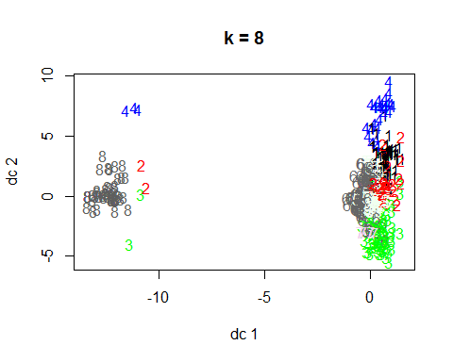

bakerycluster8$withinss

## [1] 223.93258 183.65333 230.53012 67.22449 1064.38287 650.93304  
## [7] 14.27586 150.77778

bakerycluster8$tot.withinss

## [1] 2585.71

bakerycluster8$betweenss

## [1] 715.7529

bakerycluster8$totss

## [1] 3301.463

clusters4<- bakerycluster4$tot.withinss/bakerycluster4$totss  
clusters5<- bakerycluster5$tot.withinss/bakerycluster5$totss  
clusters6<- bakerycluster6$tot.withinss/bakerycluster6$totss  
clusters7<- bakerycluster7$tot.withinss/bakerycluster7$totss  
clusters8<- bakerycluster8$tot.withinss/bakerycluster8$totss  
totwithinss.metric <- c(clusters4, clusters5, clusters6, clusters7, clusters8)  
print(totwithinss.metric)

## [1] 0.8884603 0.8805925 0.8310576 0.7971675 0.7832013

clusters4<- bakerycluster4$betweenss/bakerycluster4$totss  
clusters5<- bakerycluster5$betweenss/bakerycluster5$totss  
clusters6<- bakerycluster6$betweenss/bakerycluster6$totss  
clusters7<- bakerycluster7$betweenss/bakerycluster7$totss  
clusters8<- bakerycluster8$betweenss/bakerycluster8$totss  
betweenss.metric <- c(clusters4, clusters5, clusters6, clusters7, clusters8)  
print(betweenss.metric) #Look for a ratio that is closer to 1.

## [1] 0.1115397 0.1194075 0.1689424 0.2028325 0.2167987

#WithinSS  
wss <- (nrow(bakery)-1)*sum(apply(bakery,2,var))  
for (i in 1:10) wss[i] <- sum(kmeans(bakery,centers=i)$withinss)  
plot(1:10, wss, type="b", xlab="Number of Clusters",  
 ylab="Within Sum of Squares", main = "Number of Clusters (k) versus Cluster Cohesiveness")

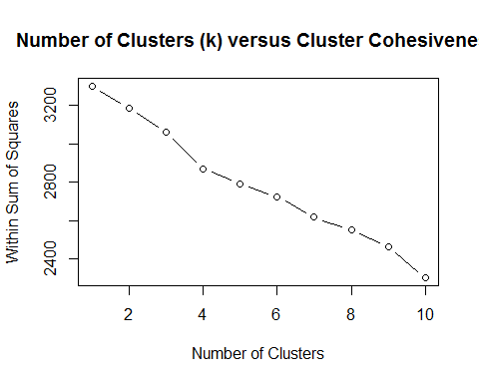

#BetweenSS  
wss <- (nrow(bakery)-1)*sum(apply(bakery,2,var))  
for (i in 1:10) wss[i] <- sum(kmeans(bakery,centers=i)$betweenss)  
plot(1:10, wss, type="b", xlab="Number of Clusters",  
 ylab="Between Group Sum of Squares", main = "Number of Clusters (k) versus Cluster Distinctiveness")

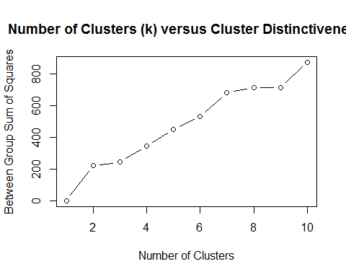

library(clusterSim)

## Warning: package 'clusterSim' was built under R version 3.3.3

## Loading required package: cluster

## Loading required package: MASS

##   
## This is package 'modeest' written by P. PONCET.  
## For a complete list of functions, use 'library(help = "modeest")' or 'help.start()'.

#?index.G1 #read the ../doc/indexG1_details.pdf  
  
a<-index.G1(bakery, bakerycluster4$cluster, centrotypes = "centroids")   
b<-index.G1(bakery, bakerycluster5$cluster, centrotypes = "centroids")  
c<-index.G1(bakery, bakerycluster6$cluster, centrotypes = "centroids")  
d<-index.G1(bakery, bakerycluster7$cluster, centrotypes = "centroids")  
e<-index.G1(bakery, bakerycluster8$cluster, centrotypes = "centroids")  
pseudoF<-c(a,b,c,d,e)  
pseudoF

## [1] 41.68018 33.73026 40.41326 42.11007 39.22807

bakerycluster4$size

## [1] 536 82 91 291

Clusters_4<-data.frame(bakerycluster4$centers)  
Clusters_4<-data.frame(t(bakerycluster4$centers))   
  
bakerycluster5$size

## [1] 118 104 103 131 544

Clusters_5<-data.frame(bakerycluster5$centers)  
Clusters_5<-data.frame(t(bakerycluster5$centers))   
  
bakerycluster6$size

## [1] 87 76 84 49 456 248

Clusters_6<-data.frame(bakerycluster6$centers)  
Clusters_6<-data.frame(t(bakerycluster6$centers))   
  
bakerycluster7$size

## [1] 92 76 77 49 431 246 29

Clusters_7<-data.frame(bakerycluster7$centers)  
Clusters_7<-data.frame(t(bakerycluster7$centers))   
  
bakerycluster8$size

## [1] 89 75 83 49 397 224 29 54

Clusters_8<-data.frame(bakerycluster8$centers)  
Clusters_8<-data.frame(t(bakerycluster8$centers))   
  
bakery$cluster <- bakerycluster7$cluster  
aggregate(data = bakery, Weekend ~ cluster, mean)

## cluster Weekend  
## 1 1 0.1847826  
## 2 2 0.1184211  
## 3 3 0.2077922  
## 4 4 0.3877551  
## 5 5 0.0000000  
## 6 6 1.0000000  
## 7 7 0.2758621

HW3_weekday.R

Jennifer

Tue Apr 04 12:09:41 2017

setwd("C:/Users/Jennifer/Documents/ADM/HW 3")  
bakery<-read.csv("bakery_binary.csv")  
str(bakery)

## 'data.frame': 1000 obs. of 51 variables:  
## $ Chocolate.Cake : int 0 0 1 0 0 0 0 0 1 1 ...  
## $ Lemon.Cake : int 0 0 0 0 0 0 0 0 0 0 ...  
## $ Casino.Cake : int 0 0 0 1 1 0 0 0 0 1 ...  
## $ Opera.Cake : int 0 1 0 0 0 0 1 1 0 0 ...  
## $ Strawberry.Cake : int 0 0 1 0 0 0 0 0 0 0 ...  
## $ Truffle.Cake : int 0 0 0 0 0 0 0 0 0 0 ...  
## $ Chocolate.Eclair : int 0 0 0 1 0 0 0 1 0 0 ...  
## $ Coffee.Eclair : int 0 0 0 0 0 0 0 0 0 0 ...  
## $ Vanilla.Eclair : int 0 0 0 0 0 0 0 0 0 0 ...  
## $ Napoleon.Cake : int 0 0 1 0 0 1 0 0 0 0 ...  
## $ Almond.Tart : int 0 0 0 0 1 0 0 0 0 0 ...  
## $ Apple.Pie : int 0 0 0 0 0 0 0 0 0 0 ...  
## $ Apple.Tart : int 0 0 0 0 0 0 0 0 0 0 ...  
## $ Apricot.Tart : int 0 0 0 0 0 0 0 1 0 0 ...  
## $ Berry.Tart : int 0 0 0 0 0 0 0 0 0 0 ...  
## $ Blackberry.Tart : int 1 0 0 0 0 0 0 0 0 0 ...  
## $ Blueberry.Tart : int 0 0 0 0 0 0 0 0 0 0 ...  
## $ Chocolate.Tart : int 0 0 0 0 0 0 0 0 0 0 ...  
## $ Cherry.Tart : int 0 1 0 0 0 0 0 0 0 0 ...  
## $ Lemon.Tart : int 0 0 0 0 0 0 0 0 0 0 ...  
## $ Pecan.Tart : int 0 0 0 0 0 0 0 0 0 0 ...  
## $ Ganache.Cookie : int 0 0 0 0 0 0 0 0 0 0 ...  
## $ Gongolais.Cookie : int 0 0 0 1 1 0 0 0 0 0 ...  
## $ Raspberry.Cookie : int 0 0 0 0 0 0 0 0 0 0 ...  
## $ Lemon.Cookie : int 0 0 0 0 0 0 0 0 0 0 ...  
## $ Chocolate.Meringue : int 0 0 0 0 0 0 0 0 0 0 ...  
## $ Vanilla.Meringue : int 0 0 0 0 0 0 0 0 0 0 ...  
## $ Marzipan.Cookie : int 0 0 0 0 0 1 0 0 0 0 ...  
## $ Tuile.Cookie : int 0 0 0 0 0 1 0 0 0 0 ...  
## $ Walnut.Cookie : int 0 0 0 0 0 0 1 0 0 0 ...  
## $ Almond.Croissant : int 0 0 1 0 0 0 0 0 0 0 ...  
## $ Apple.Croissant : int 0 0 0 0 1 0 0 0 0 0 ...  
## $ Apricot.Croissant : int 0 0 0 1 0 0 0 0 0 0 ...  
## $ Cheese.Croissant : int 0 0 1 0 1 0 0 0 0 0 ...  
## $ Chocolate.Croissant: int 1 0 0 0 0 0 0 0 0 0 ...  
## $ Apricot.Danish : int 0 1 0 0 0 0 0 0 0 0 ...  
## $ Apple.Danish : int 0 0 0 0 0 0 0 0 0 0 ...  
## $ Almond.Twist : int 0 0 0 0 0 0 0 0 0 0 ...  
## $ Almond.Bear.Claw : int 0 0 0 0 0 0 0 0 0 0 ...  
## $ Blueberry.Danish : int 0 0 0 0 0 0 0 0 0 0 ...  
## $ Lemon.Lemonade : int 0 0 0 0 0 0 0 0 0 0 ...  
## $ Raspberry.Lemonade : int 0 0 0 0 0 0 0 0 0 0 ...  
## $ Orange.Juice : int 0 0 0 0 0 0 0 0 0 0 ...  
## $ Green.Tea : int 0 0 0 0 0 0 0 0 0 0 ...  
## $ Bottled.Water : int 0 0 0 0 0 0 1 0 0 0 ...  
## $ Hot.Coffee : int 0 0 0 0 0 1 0 0 0 0 ...  
## $ Chocolate.Coffee : int 0 0 0 0 1 0 0 0 0 1 ...  
## $ Vanilla.Frappuccino: int 1 0 0 0 0 0 0 0 0 0 ...  
## $ Cherry.Soda : int 0 0 0 0 0 0 0 0 0 0 ...  
## $ Single.Espresso : int 0 0 0 0 0 0 0 0 0 0 ...  
## $ Weekend : int 0 0 1 1 0 0 0 0 0 0 ...

summary(bakery)

## Chocolate.Cake Lemon.Cake Casino.Cake Opera.Cake   
## Min. :0.000 Min. :0.000 Min. :0.000 Min. :0.000   
## 1st Qu.:0.000 1st Qu.:0.000 1st Qu.:0.000 1st Qu.:0.000   
## Median :0.000 Median :0.000 Median :0.000 Median :0.000   
## Mean :0.084 Mean :0.085 Mean :0.072 Mean :0.078   
## 3rd Qu.:0.000 3rd Qu.:0.000 3rd Qu.:0.000 3rd Qu.:0.000   
## Max. :1.000 Max. :1.000 Max. :1.000 Max. :1.000   
## Strawberry.Cake Truffle.Cake Chocolate.Eclair Coffee.Eclair   
## Min. :0.000 Min. :0.000 Min. :0.000 Min. :0.000   
## 1st Qu.:0.000 1st Qu.:0.000 1st Qu.:0.000 1st Qu.:0.000   
## Median :0.000 Median :0.000 Median :0.000 Median :0.000   
## Mean :0.091 Mean :0.103 Mean :0.034 Mean :0.093   
## 3rd Qu.:0.000 3rd Qu.:0.000 3rd Qu.:0.000 3rd Qu.:0.000   
## Max. :1.000 Max. :1.000 Max. :1.000 Max. :1.000   
## Vanilla.Eclair Napoleon.Cake Almond.Tart Apple.Pie   
## Min. :0.000 Min. :0.00 Min. :0.000 Min. :0.000   
## 1st Qu.:0.000 1st Qu.:0.00 1st Qu.:0.000 1st Qu.:0.000   
## Median :0.000 Median :0.00 Median :0.000 Median :0.000   
## Mean :0.037 Mean :0.09 Mean :0.041 Mean :0.068   
## 3rd Qu.:0.000 3rd Qu.:0.00 3rd Qu.:0.000 3rd Qu.:0.000   
## Max. :1.000 Max. :1.00 Max. :1.000 Max. :1.000   
## Apple.Tart Apricot.Tart Berry.Tart Blackberry.Tart  
## Min. :0.000 Min. :0.000 Min. :0.000 Min. :0.000   
## 1st Qu.:0.000 1st Qu.:0.000 1st Qu.:0.000 1st Qu.:0.000   
## Median :0.000 Median :0.000 Median :0.000 Median :0.000   
## Mean :0.079 Mean :0.056 Mean :0.095 Mean :0.073   
## 3rd Qu.:0.000 3rd Qu.:0.000 3rd Qu.:0.000 3rd Qu.:0.000   
## Max. :1.000 Max. :1.000 Max. :1.000 Max. :1.000   
## Blueberry.Tart Chocolate.Tart Cherry.Tart Lemon.Tart   
## Min. :0.000 Min. :0.000 Min. :0.000 Min. :0.000   
## 1st Qu.:0.000 1st Qu.:0.000 1st Qu.:0.000 1st Qu.:0.000   
## Median :0.000 Median :0.000 Median :0.000 Median :0.000   
## Mean :0.081 Mean :0.051 Mean :0.084 Mean :0.076   
## 3rd Qu.:0.000 3rd Qu.:0.000 3rd Qu.:0.000 3rd Qu.:0.000   
## Max. :1.000 Max. :1.000 Max. :1.000 Max. :1.000   
## Pecan.Tart Ganache.Cookie Gongolais.Cookie Raspberry.Cookie  
## Min. :0.00 Min. :0.000 Min. :0.000 Min. :0.000   
## 1st Qu.:0.00 1st Qu.:0.000 1st Qu.:0.000 1st Qu.:0.000   
## Median :0.00 Median :0.000 Median :0.000 Median :0.000   
## Mean :0.04 Mean :0.044 Mean :0.108 Mean :0.082   
## 3rd Qu.:0.00 3rd Qu.:0.000 3rd Qu.:0.000 3rd Qu.:0.000   
## Max. :1.00 Max. :1.000 Max. :1.000 Max. :1.000   
## Lemon.Cookie Chocolate.Meringue Vanilla.Meringue Marzipan.Cookie  
## Min. :0.000 Min. :0.000 Min. :0.000 Min. :0.00   
## 1st Qu.:0.000 1st Qu.:0.000 1st Qu.:0.000 1st Qu.:0.00   
## Median :0.000 Median :0.000 Median :0.000 Median :0.00   
## Mean :0.066 Mean :0.038 Mean :0.047 Mean :0.09   
## 3rd Qu.:0.000 3rd Qu.:0.000 3rd Qu.:0.000 3rd Qu.:0.00   
## Max. :1.000 Max. :1.000 Max. :1.000 Max. :1.00   
## Tuile.Cookie Walnut.Cookie Almond.Croissant Apple.Croissant  
## Min. :0.000 Min. :0.000 Min. :0.000 Min. :0.000   
## 1st Qu.:0.000 1st Qu.:0.000 1st Qu.:0.000 1st Qu.:0.000   
## Median :0.000 Median :0.000 Median :0.000 Median :0.000   
## Mean :0.102 Mean :0.061 Mean :0.049 Mean :0.091   
## 3rd Qu.:0.000 3rd Qu.:0.000 3rd Qu.:0.000 3rd Qu.:0.000   
## Max. :1.000 Max. :1.000 Max. :1.000 Max. :1.000   
## Apricot.Croissant Cheese.Croissant Chocolate.Croissant Apricot.Danish   
## Min. :0.000 Min. :0.000 Min. :0.000 Min. :0.000   
## 1st Qu.:0.000 1st Qu.:0.000 1st Qu.:0.000 1st Qu.:0.000   
## Median :0.000 Median :0.000 Median :0.000 Median :0.000   
## Mean :0.076 Mean :0.078 Mean :0.042 Mean :0.075   
## 3rd Qu.:0.000 3rd Qu.:0.000 3rd Qu.:0.000 3rd Qu.:0.000   
## Max. :1.000 Max. :1.000 Max. :1.000 Max. :1.000   
## Apple.Danish Almond.Twist Almond.Bear.Claw Blueberry.Danish  
## Min. :0.000 Min. :0.000 Min. :0.000 Min. :0.000   
## 1st Qu.:0.000 1st Qu.:0.000 1st Qu.:0.000 1st Qu.:0.000   
## Median :0.000 Median :0.000 Median :0.000 Median :0.000   
## Mean :0.084 Mean :0.065 Mean :0.026 Mean :0.055   
## 3rd Qu.:0.000 3rd Qu.:0.000 3rd Qu.:0.000 3rd Qu.:0.000   
## Max. :1.000 Max. :1.000 Max. :1.000 Max. :1.000   
## Lemon.Lemonade Raspberry.Lemonade Orange.Juice Green.Tea   
## Min. :0.000 Min. :0.000 Min. :0.000 Min. :0.000   
## 1st Qu.:0.000 1st Qu.:0.000 1st Qu.:0.000 1st Qu.:0.000   
## Median :0.000 Median :0.000 Median :0.000 Median :0.000   
## Mean :0.066 Mean :0.072 Mean :0.082 Mean :0.062   
## 3rd Qu.:0.000 3rd Qu.:0.000 3rd Qu.:0.000 3rd Qu.:0.000   
## Max. :1.000 Max. :1.000 Max. :1.000 Max. :1.000   
## Bottled.Water Hot.Coffee Chocolate.Coffee Vanilla.Frappuccino  
## Min. :0.000 Min. :0.000 Min. :0.000 Min. :0.000   
## 1st Qu.:0.000 1st Qu.:0.000 1st Qu.:0.000 1st Qu.:0.000   
## Median :0.000 Median :0.000 Median :0.000 Median :0.000   
## Mean :0.077 Mean :0.094 Mean :0.085 Mean :0.074   
## 3rd Qu.:0.000 3rd Qu.:0.000 3rd Qu.:0.000 3rd Qu.:0.000   
## Max. :1.000 Max. :1.000 Max. :1.000 Max. :1.000   
## Cherry.Soda Single.Espresso Weekend   
## Min. :0.000 Min. :0.000 Min. :0.000   
## 1st Qu.:0.000 1st Qu.:0.000 1st Qu.:0.000   
## Median :0.000 Median :0.000 Median :0.000   
## Mean :0.077 Mean :0.059 Mean :0.315   
## 3rd Qu.:0.000 3rd Qu.:0.000 3rd Qu.:1.000   
## Max. :1.000 Max. :1.000 Max. :1.000

bakery<-bakery[,c(1:6, 8:10, 12:13, 15:17, 19:21, 23:38, 40:51)]   
bakeryweekday=bakery[!(bakery$Weekend=="1"),]  
str(bakeryweekday)

## 'data.frame': 685 obs. of 45 variables:  
## $ Chocolate.Cake : int 0 0 0 0 0 0 1 1 0 1 ...  
## $ Lemon.Cake : int 0 0 0 0 0 0 0 0 0 0 ...  
## $ Casino.Cake : int 0 0 1 0 0 0 0 1 0 1 ...  
## $ Opera.Cake : int 0 1 0 0 1 1 0 0 0 0 ...  
## $ Strawberry.Cake : int 0 0 0 0 0 0 0 0 0 0 ...  
## $ Truffle.Cake : int 0 0 0 0 0 0 0 0 0 0 ...  
## $ Coffee.Eclair : int 0 0 0 0 0 0 0 0 0 0 ...  
## $ Vanilla.Eclair : int 0 0 0 0 0 0 0 0 0 0 ...  
## $ Napoleon.Cake : int 0 0 0 1 0 0 0 0 0 0 ...  
## $ Apple.Pie : int 0 0 0 0 0 0 0 0 0 0 ...  
## $ Apple.Tart : int 0 0 0 0 0 0 0 0 0 0 ...  
## $ Berry.Tart : int 0 0 0 0 0 0 0 0 0 0 ...  
## $ Blackberry.Tart : int 1 0 0 0 0 0 0 0 0 0 ...  
## $ Blueberry.Tart : int 0 0 0 0 0 0 0 0 0 0 ...  
## $ Cherry.Tart : int 0 1 0 0 0 0 0 0 0 0 ...  
## $ Lemon.Tart : int 0 0 0 0 0 0 0 0 0 0 ...  
## $ Pecan.Tart : int 0 0 0 0 0 0 0 0 0 0 ...  
## $ Gongolais.Cookie : int 0 0 1 0 0 0 0 0 0 0 ...  
## $ Raspberry.Cookie : int 0 0 0 0 0 0 0 0 0 0 ...  
## $ Lemon.Cookie : int 0 0 0 0 0 0 0 0 0 0 ...  
## $ Chocolate.Meringue : int 0 0 0 0 0 0 0 0 0 0 ...  
## $ Vanilla.Meringue : int 0 0 0 0 0 0 0 0 0 0 ...  
## $ Marzipan.Cookie : int 0 0 0 1 0 0 0 0 0 0 ...  
## $ Tuile.Cookie : int 0 0 0 1 0 0 0 0 0 0 ...  
## $ Walnut.Cookie : int 0 0 0 0 1 0 0 0 0 0 ...  
## $ Almond.Croissant : int 0 0 0 0 0 0 0 0 0 0 ...  
## $ Apple.Croissant : int 0 0 1 0 0 0 0 0 0 0 ...  
## $ Apricot.Croissant : int 0 0 0 0 0 0 0 0 0 0 ...  
## $ Cheese.Croissant : int 0 0 1 0 0 0 0 0 0 0 ...  
## $ Chocolate.Croissant: int 1 0 0 0 0 0 0 0 1 0 ...  
## $ Apricot.Danish : int 0 1 0 0 0 0 0 0 0 0 ...  
## $ Apple.Danish : int 0 0 0 0 0 0 0 0 0 0 ...  
## $ Almond.Twist : int 0 0 0 0 0 0 0 0 0 0 ...  
## $ Blueberry.Danish : int 0 0 0 0 0 0 0 0 0 0 ...  
## $ Lemon.Lemonade : int 0 0 0 0 0 0 0 0 0 0 ...  
## $ Raspberry.Lemonade : int 0 0 0 0 0 0 0 0 0 0 ...  
## $ Orange.Juice : int 0 0 0 0 0 0 0 0 0 0 ...  
## $ Green.Tea : int 0 0 0 0 0 0 0 0 0 0 ...  
## $ Bottled.Water : int 0 0 0 0 1 0 0 0 0 0 ...  
## $ Hot.Coffee : int 0 0 0 1 0 0 0 0 0 0 ...  
## $ Chocolate.Coffee : int 0 0 1 0 0 0 0 1 0 1 ...  
## $ Vanilla.Frappuccino: int 1 0 0 0 0 0 0 0 0 0 ...  
## $ Cherry.Soda : int 0 0 0 0 0 0 0 0 0 0 ...  
## $ Single.Espresso : int 0 0 0 0 0 0 0 0 0 0 ...  
## $ Weekend : int 0 0 0 0 0 0 0 0 0 0 ...

summary(bakeryweekday)

## Chocolate.Cake Lemon.Cake Casino.Cake Opera.Cake   
## Min. :0.00000 Min. :0.00000 Min. :0.00000 Min. :0.00000   
## 1st Qu.:0.00000 1st Qu.:0.00000 1st Qu.:0.00000 1st Qu.:0.00000   
## Median :0.00000 Median :0.00000 Median :0.00000 Median :0.00000   
## Mean :0.08175 Mean :0.07883 Mean :0.07299 Mean :0.06715   
## 3rd Qu.:0.00000 3rd Qu.:0.00000 3rd Qu.:0.00000 3rd Qu.:0.00000   
## Max. :1.00000 Max. :1.00000 Max. :1.00000 Max. :1.00000   
## Strawberry.Cake Truffle.Cake Coffee.Eclair Vanilla.Eclair   
## Min. :0.00000 Min. :0.0000 Min. :0.00000 Min. :0.00000   
## 1st Qu.:0.00000 1st Qu.:0.0000 1st Qu.:0.00000 1st Qu.:0.00000   
## Median :0.00000 Median :0.0000 Median :0.00000 Median :0.00000   
## Mean :0.09489 Mean :0.1124 Mean :0.08905 Mean :0.04088   
## 3rd Qu.:0.00000 3rd Qu.:0.0000 3rd Qu.:0.00000 3rd Qu.:0.00000   
## Max. :1.00000 Max. :1.0000 Max. :1.00000 Max. :1.00000   
## Napoleon.Cake Apple.Pie Apple.Tart Berry.Tart   
## Min. :0.00000 Min. :0.00000 Min. :0.00000 Min. :0.00000   
## 1st Qu.:0.00000 1st Qu.:0.00000 1st Qu.:0.00000 1st Qu.:0.00000   
## Median :0.00000 Median :0.00000 Median :0.00000 Median :0.00000   
## Mean :0.08029 Mean :0.05255 Mean :0.07737 Mean :0.09343   
## 3rd Qu.:0.00000 3rd Qu.:0.00000 3rd Qu.:0.00000 3rd Qu.:0.00000   
## Max. :1.00000 Max. :1.00000 Max. :1.00000 Max. :1.00000   
## Blackberry.Tart Blueberry.Tart Cherry.Tart Lemon.Tart   
## Min. :0.00000 Min. :0.00000 Min. :0.00000 Min. :0.00000   
## 1st Qu.:0.00000 1st Qu.:0.00000 1st Qu.:0.00000 1st Qu.:0.00000   
## Median :0.00000 Median :0.00000 Median :0.00000 Median :0.00000   
## Mean :0.07007 Mean :0.09051 Mean :0.08029 Mean :0.07591   
## 3rd Qu.:0.00000 3rd Qu.:0.00000 3rd Qu.:0.00000 3rd Qu.:0.00000   
## Max. :1.00000 Max. :1.00000 Max. :1.00000 Max. :1.00000   
## Pecan.Tart Gongolais.Cookie Raspberry.Cookie Lemon.Cookie   
## Min. :0.00000 Min. :0.0000 Min. :0.00000 Min. :0.00000   
## 1st Qu.:0.00000 1st Qu.:0.0000 1st Qu.:0.00000 1st Qu.:0.00000   
## Median :0.00000 Median :0.0000 Median :0.00000 Median :0.00000   
## Mean :0.04234 Mean :0.1153 Mean :0.08321 Mean :0.07591   
## 3rd Qu.:0.00000 3rd Qu.:0.0000 3rd Qu.:0.00000 3rd Qu.:0.00000   
## Max. :1.00000 Max. :1.0000 Max. :1.00000 Max. :1.00000   
## Chocolate.Meringue Vanilla.Meringue Marzipan.Cookie Tuile.Cookie   
## Min. :0.00000 Min. :0.00000 Min. :0.000 Min. :0.0000   
## 1st Qu.:0.00000 1st Qu.:0.00000 1st Qu.:0.000 1st Qu.:0.0000   
## Median :0.00000 Median :0.00000 Median :0.000 Median :0.0000   
## Mean :0.04526 Mean :0.04526 Mean :0.108 Mean :0.1109   
## 3rd Qu.:0.00000 3rd Qu.:0.00000 3rd Qu.:0.000 3rd Qu.:0.0000   
## Max. :1.00000 Max. :1.00000 Max. :1.000 Max. :1.0000   
## Walnut.Cookie Almond.Croissant Apple.Croissant Apricot.Croissant  
## Min. :0.00000 Min. :0.00000 Min. :0.00000 Min. :0.00000   
## 1st Qu.:0.00000 1st Qu.:0.00000 1st Qu.:0.00000 1st Qu.:0.00000   
## Median :0.00000 Median :0.00000 Median :0.00000 Median :0.00000   
## Mean :0.05255 Mean :0.05109 Mean :0.09051 Mean :0.08321   
## 3rd Qu.:0.00000 3rd Qu.:0.00000 3rd Qu.:0.00000 3rd Qu.:0.00000   
## Max. :1.00000 Max. :1.00000 Max. :1.00000 Max. :1.00000   
## Cheese.Croissant Chocolate.Croissant Apricot.Danish Apple.Danish   
## Min. :0.00000 Min. :0.00000 Min. :0.00000 Min. :0.00000   
## 1st Qu.:0.00000 1st Qu.:0.00000 1st Qu.:0.00000 1st Qu.:0.00000   
## Median :0.00000 Median :0.00000 Median :0.00000 Median :0.00000   
## Mean :0.07445 Mean :0.04818 Mean :0.06715 Mean :0.07883   
## 3rd Qu.:0.00000 3rd Qu.:0.00000 3rd Qu.:0.00000 3rd Qu.:0.00000   
## Max. :1.00000 Max. :1.00000 Max. :1.00000 Max. :1.00000   
## Almond.Twist Blueberry.Danish Lemon.Lemonade Raspberry.Lemonade  
## Min. :0.00000 Min. :0.00000 Min. :0.00000 Min. :0.00000   
## 1st Qu.:0.00000 1st Qu.:0.00000 1st Qu.:0.00000 1st Qu.:0.00000   
## Median :0.00000 Median :0.00000 Median :0.00000 Median :0.00000   
## Mean :0.06423 Mean :0.06277 Mean :0.06423 Mean :0.07153   
## 3rd Qu.:0.00000 3rd Qu.:0.00000 3rd Qu.:0.00000 3rd Qu.:0.00000   
## Max. :1.00000 Max. :1.00000 Max. :1.00000 Max. :1.00000   
## Orange.Juice Green.Tea Bottled.Water Hot.Coffee   
## Min. :0.00000 Min. :0.00000 Min. :0.00000 Min. :0.00000   
## 1st Qu.:0.00000 1st Qu.:0.00000 1st Qu.:0.00000 1st Qu.:0.00000   
## Median :0.00000 Median :0.00000 Median :0.00000 Median :0.00000   
## Mean :0.07737 Mean :0.06715 Mean :0.07883 Mean :0.09343   
## 3rd Qu.:0.00000 3rd Qu.:0.00000 3rd Qu.:0.00000 3rd Qu.:0.00000   
## Max. :1.00000 Max. :1.00000 Max. :1.00000 Max. :1.00000   
## Chocolate.Coffee Vanilla.Frappuccino Cherry.Soda Single.Espresso   
## Min. :0.00000 Min. :0.00000 Min. :0.00000 Min. :0.00000   
## 1st Qu.:0.00000 1st Qu.:0.00000 1st Qu.:0.00000 1st Qu.:0.00000   
## Median :0.00000 Median :0.00000 Median :0.00000 Median :0.00000   
## Mean :0.08613 Mean :0.06423 Mean :0.08175 Mean :0.06423   
## 3rd Qu.:0.00000 3rd Qu.:0.00000 3rd Qu.:0.00000 3rd Qu.:0.00000   
## Max. :1.00000 Max. :1.00000 Max. :1.00000 Max. :1.00000   
## Weekend   
## Min. :0   
## 1st Qu.:0   
## Median :0   
## Mean :0   
## 3rd Qu.:0   
## Max. :0

set.seed(123)  
bakeryclusterwd4 <- kmeans(bakeryweekday, centers=4)   
bakeryclusterwd4$size

## [1] 31 62 21 571

names(bakeryclusterwd4)

## [1] "cluster" "centers" "totss" "withinss"   
## [5] "tot.withinss" "betweenss" "size" "iter"   
## [9] "ifault"

library(fpc)

## Warning: package 'fpc' was built under R version 3.3.3

plotcluster(bakeryweekday, bakeryclusterwd4$cluster, main="k=4")

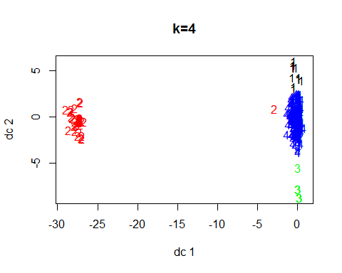

bakeryclusterwd4$withinss

## [1] 26.451613 144.500000 5.619048 1665.856392

bakeryclusterwd4$tot.withinss

## [1] 1842.427

bakeryclusterwd4$betweenss

## [1] 242.2474

bakeryclusterwd4$totss

## [1] 2084.674

set.seed(123)  
bakeryclusterwd5 <- kmeans(bakeryweekday, centers=5)   
bakeryclusterwd5$size

## [1] 31 23 21 538 72

plotcluster(bakeryweekday, bakeryclusterwd5$cluster, main="k = 5")

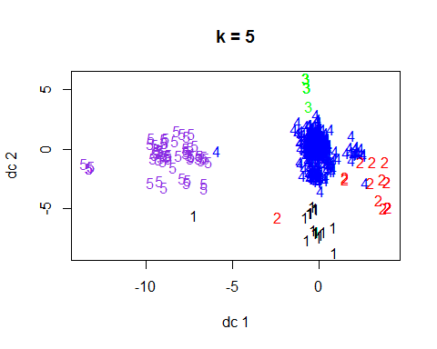

bakeryclusterwd5$withinss

## [1] 26.451613 32.434783 5.619048 1542.708178 197.180556

bakeryclusterwd5$tot.withinss

## [1] 1804.394

bakeryclusterwd5$betweenss

## [1] 280.2803

bakeryclusterwd5$totss

## [1] 2084.674

set.seed(123)  
bakeryclusterwd6 <- kmeans(bakeryweekday, centers=6)   
bakeryclusterwd6$size

## [1] 80 96 21 419 45 24

plotcluster(bakeryweekday, bakeryclusterwd6$cluster, main="k = 6")

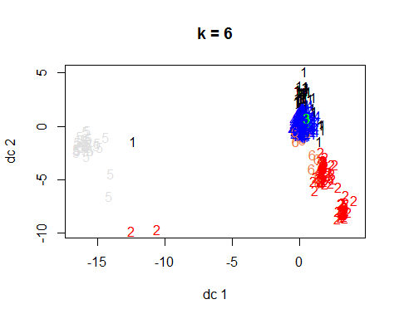

bakeryclusterwd6$withinss

## [1] 209.837500 226.541667 5.619048 1135.832936 93.822222 36.083333

bakeryclusterwd6$tot.withinss

## [1] 1707.737

bakeryclusterwd6$betweenss

## [1] 376.9377

bakeryclusterwd6$totss

## [1] 2084.674

set.seed(123)  
bakeryclusterwd7 <- kmeans(bakeryweekday, centers=7)   
bakeryclusterwd7$size

## [1] 31 97 21 434 46 23 33

plotcluster(bakeryweekday, bakeryclusterwd7$cluster, main="k = 7")

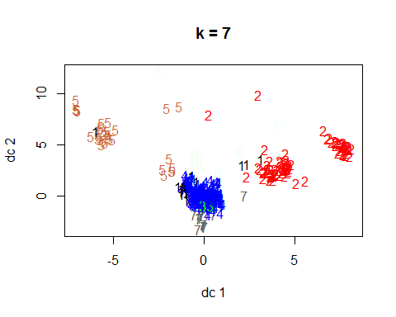

bakeryclusterwd7$withinss

## [1] 26.451613 230.907216 5.619048 1191.009217 102.565217 32.434783  
## [7] 41.030303

bakeryclusterwd7$tot.withinss

## [1] 1630.017

bakeryclusterwd7$betweenss

## [1] 454.6571

bakeryclusterwd7$totss

## [1] 2084.674

set.seed(123)  
bakeryclusterwd8 <- kmeans(bakeryweekday, centers=8)   
bakeryclusterwd8$size

## [1] 31 87 21 348 43 23 33 99

plotcluster(bakeryweekday, bakeryclusterwd8$cluster, main="k = 8")

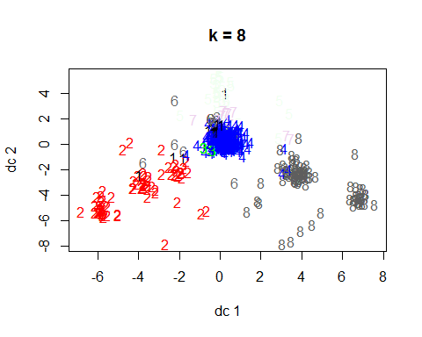

bakeryclusterwd8$withinss

## [1] 26.451613 181.333333 5.619048 929.071839 92.558140 32.434783  
## [7] 41.030303 239.111111

bakeryclusterwd8$tot.withinss

## [1] 1547.61

bakeryclusterwd8$betweenss

## [1] 537.0643

bakeryclusterwd8$totss

## [1] 2084.674

clusterswd4<- bakeryclusterwd4$tot.withinss/bakeryclusterwd4$totss  
clusterswd5<- bakeryclusterwd5$tot.withinss/bakeryclusterwd5$totss  
clusterswd6<- bakeryclusterwd6$tot.withinss/bakeryclusterwd6$totss  
clusterswd7<- bakeryclusterwd7$tot.withinss/bakeryclusterwd7$totss  
clusterswd8<- bakeryclusterwd8$tot.withinss/bakeryclusterwd8$totss  
totwithinss.metric <- c(clusterswd4, clusterswd5, clusterswd6, clusterswd7, clusterswd8)  
print(totwithinss.metric)

## [1] 0.8837961 0.8655520 0.8191863 0.7819050 0.7423750

clusterswd4<- bakeryclusterwd4$betweenss/bakeryclusterwd4$totss  
clusterswd5<- bakeryclusterwd5$betweenss/bakeryclusterwd5$totss  
clusterswd6<- bakeryclusterwd6$betweenss/bakeryclusterwd6$totss  
clusterswd7<- bakeryclusterwd7$betweenss/bakeryclusterwd7$totss  
clusterswd8<- bakeryclusterwd8$betweenss/bakeryclusterwd8$totss  
betweenss.metric <- c(clusterswd4, clusterswd5, clusterswd6, clusterswd7, clusterswd8)  
print(betweenss.metric) #Look for a ratio that is closer to 1.

## [1] 0.1162039 0.1344480 0.1808137 0.2180950 0.2576250

#WithinSS  
wss <- (nrow(bakeryweekday)-1)*sum(apply(bakeryweekday,2,var))  
for (i in 1:10) wss[i] <- sum(kmeans(bakeryweekday,centers=i)$withinss)  
plot(1:10, wss, type="b", xlab="Number of Clusters",  
 ylab="Within Sum of Squares", main = "Number of Clusters (k) versus Cluster Cohesiveness")

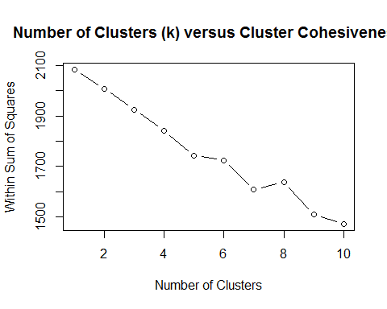

#BetweenSS  
wss <- (nrow(bakeryweekday)-1)*sum(apply(bakeryweekday,2,var))  
for (i in 1:10) wss[i] <- sum(kmeans(bakeryweekday,centers=i)$betweenss)  
plot(1:10, wss, type="b", xlab="Number of Clusters",  
 ylab="Between Group Sum of Squares", main = "Number of Clusters (k) versus Cluster Distinctiveness")

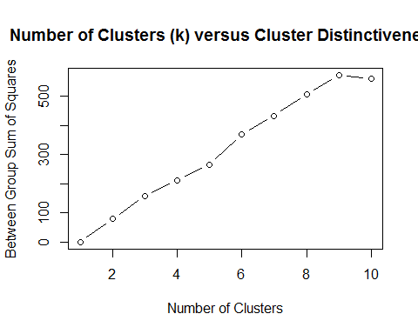

library(clusterSim)

## Warning: package 'clusterSim' was built under R version 3.3.3

## Loading required package: cluster

## Loading required package: MASS

##   
## This is package 'modeest' written by P. PONCET.  
## For a complete list of functions, use 'library(help = "modeest")' or 'help.start()'.

#?index.G1 #read the ../doc/indexG1_details.pdf  
  
a<-index.G1(bakeryweekday, bakeryclusterwd4$cluster, centrotypes = "centroids")   
b<-index.G1(bakeryweekday, bakeryclusterwd5$cluster, centrotypes = "centroids")  
c<-index.G1(bakeryweekday, bakeryclusterwd6$cluster, centrotypes = "centroids")  
d<-index.G1(bakeryweekday, bakeryclusterwd7$cluster, centrotypes = "centroids")  
e<-index.G1(bakeryweekday, bakeryclusterwd8$cluster, centrotypes = "centroids")  
pseudoF<-c(a,b,c,d,e)  
pseudoF

## [1] 29.84659 26.40645 29.97426 31.51883 33.56258

bakeryclusterwd4$size

## [1] 31 62 21 571

Clusterswd_4<-data.frame(bakeryclusterwd4$centers)  
Clusterswd_4<-data.frame(t(bakeryclusterwd4$centers))   
  
bakeryclusterwd5$size

## [1] 31 23 21 538 72

Clusterswd_5<-data.frame(bakeryclusterwd5$centers)  
Clusterswd_5<-data.frame(t(bakeryclusterwd5$centers))   
  
bakeryclusterwd6$size

## [1] 80 96 21 419 45 24

Clusterswd_6<-data.frame(bakeryclusterwd6$centers)  
Clusterswd_6<-data.frame(t(bakeryclusterwd6$centers))   
  
bakeryclusterwd7$size

## [1] 31 97 21 434 46 23 33

Clusterswd_7<-data.frame(bakeryclusterwd7$centers)  
Clusterswd_7<-data.frame(t(bakeryclusterwd7$centers))   
  
bakeryclusterwd8$size

## [1] 31 87 21 348 43 23 33 99

Clusterswd_8<-data.frame(bakeryclusterwd8$centers)  
Clusterswd_8<-data.frame(t(bakeryclusterwd8$centers))   
  
bakeryweekday$cluster <- bakeryclusterwd7$cluster  
aggregate(data = bakeryweekday, Weekend ~ cluster, mean)

## cluster Weekend  
## 1 1 0  
## 2 2 0  
## 3 3 0  
## 4 4 0  
## 5 5 0  
## 6 6 0  
## 7 7 0

HW3_weekend.R

Jennifer

Tue Apr 04 12:10:24 2017

setwd("C:/Users/Jennifer/Documents/ADM/HW 3")  
bakery<-read.csv("bakery_binary.csv")  
str(bakery)

## 'data.frame': 1000 obs. of 51 variables:  
## $ Chocolate.Cake : int 0 0 1 0 0 0 0 0 1 1 ...  
## $ Lemon.Cake : int 0 0 0 0 0 0 0 0 0 0 ...  
## $ Casino.Cake : int 0 0 0 1 1 0 0 0 0 1 ...  
## $ Opera.Cake : int 0 1 0 0 0 0 1 1 0 0 ...  
## $ Strawberry.Cake : int 0 0 1 0 0 0 0 0 0 0 ...  
## $ Truffle.Cake : int 0 0 0 0 0 0 0 0 0 0 ...  
## $ Chocolate.Eclair : int 0 0 0 1 0 0 0 1 0 0 ...  
## $ Coffee.Eclair : int 0 0 0 0 0 0 0 0 0 0 ...  
## $ Vanilla.Eclair : int 0 0 0 0 0 0 0 0 0 0 ...  
## $ Napoleon.Cake : int 0 0 1 0 0 1 0 0 0 0 ...  
## $ Almond.Tart : int 0 0 0 0 1 0 0 0 0 0 ...  
## $ Apple.Pie : int 0 0 0 0 0 0 0 0 0 0 ...  
## $ Apple.Tart : int 0 0 0 0 0 0 0 0 0 0 ...  
## $ Apricot.Tart : int 0 0 0 0 0 0 0 1 0 0 ...  
## $ Berry.Tart : int 0 0 0 0 0 0 0 0 0 0 ...  
## $ Blackberry.Tart : int 1 0 0 0 0 0 0 0 0 0 ...  
## $ Blueberry.Tart : int 0 0 0 0 0 0 0 0 0 0 ...  
## $ Chocolate.Tart : int 0 0 0 0 0 0 0 0 0 0 ...  
## $ Cherry.Tart : int 0 1 0 0 0 0 0 0 0 0 ...  
## $ Lemon.Tart : int 0 0 0 0 0 0 0 0 0 0 ...  
## $ Pecan.Tart : int 0 0 0 0 0 0 0 0 0 0 ...  
## $ Ganache.Cookie : int 0 0 0 0 0 0 0 0 0 0 ...  
## $ Gongolais.Cookie : int 0 0 0 1 1 0 0 0 0 0 ...  
## $ Raspberry.Cookie : int 0 0 0 0 0 0 0 0 0 0 ...  
## $ Lemon.Cookie : int 0 0 0 0 0 0 0 0 0 0 ...  
## $ Chocolate.Meringue : int 0 0 0 0 0 0 0 0 0 0 ...  
## $ Vanilla.Meringue : int 0 0 0 0 0 0 0 0 0 0 ...  
## $ Marzipan.Cookie : int 0 0 0 0 0 1 0 0 0 0 ...  
## $ Tuile.Cookie : int 0 0 0 0 0 1 0 0 0 0 ...  
## $ Walnut.Cookie : int 0 0 0 0 0 0 1 0 0 0 ...  
## $ Almond.Croissant : int 0 0 1 0 0 0 0 0 0 0 ...  
## $ Apple.Croissant : int 0 0 0 0 1 0 0 0 0 0 ...  
## $ Apricot.Croissant : int 0 0 0 1 0 0 0 0 0 0 ...  
## $ Cheese.Croissant : int 0 0 1 0 1 0 0 0 0 0 ...  
## $ Chocolate.Croissant: int 1 0 0 0 0 0 0 0 0 0 ...  
## $ Apricot.Danish : int 0 1 0 0 0 0 0 0 0 0 ...  
## $ Apple.Danish : int 0 0 0 0 0 0 0 0 0 0 ...  
## $ Almond.Twist : int 0 0 0 0 0 0 0 0 0 0 ...  
## $ Almond.Bear.Claw : int 0 0 0 0 0 0 0 0 0 0 ...  
## $ Blueberry.Danish : int 0 0 0 0 0 0 0 0 0 0 ...  
## $ Lemon.Lemonade : int 0 0 0 0 0 0 0 0 0 0 ...  
## $ Raspberry.Lemonade : int 0 0 0 0 0 0 0 0 0 0 ...  
## $ Orange.Juice : int 0 0 0 0 0 0 0 0 0 0 ...  
## $ Green.Tea : int 0 0 0 0 0 0 0 0 0 0 ...  
## $ Bottled.Water : int 0 0 0 0 0 0 1 0 0 0 ...  
## $ Hot.Coffee : int 0 0 0 0 0 1 0 0 0 0 ...  
## $ Chocolate.Coffee : int 0 0 0 0 1 0 0 0 0 1 ...  
## $ Vanilla.Frappuccino: int 1 0 0 0 0 0 0 0 0 0 ...  
## $ Cherry.Soda : int 0 0 0 0 0 0 0 0 0 0 ...  
## $ Single.Espresso : int 0 0 0 0 0 0 0 0 0 0 ...  
## $ Weekend : int 0 0 1 1 0 0 0 0 0 0 ...

summary(bakery)

## Chocolate.Cake Lemon.Cake Casino.Cake Opera.Cake   
## Min. :0.000 Min. :0.000 Min. :0.000 Min. :0.000   
## 1st Qu.:0.000 1st Qu.:0.000 1st Qu.:0.000 1st Qu.:0.000   
## Median :0.000 Median :0.000 Median :0.000 Median :0.000   
## Mean :0.084 Mean :0.085 Mean :0.072 Mean :0.078   
## 3rd Qu.:0.000 3rd Qu.:0.000 3rd Qu.:0.000 3rd Qu.:0.000   
## Max. :1.000 Max. :1.000 Max. :1.000 Max. :1.000   
## Strawberry.Cake Truffle.Cake Chocolate.Eclair Coffee.Eclair   
## Min. :0.000 Min. :0.000 Min. :0.000 Min. :0.000   
## 1st Qu.:0.000 1st Qu.:0.000 1st Qu.:0.000 1st Qu.:0.000   
## Median :0.000 Median :0.000 Median :0.000 Median :0.000   
## Mean :0.091 Mean :0.103 Mean :0.034 Mean :0.093   
## 3rd Qu.:0.000 3rd Qu.:0.000 3rd Qu.:0.000 3rd Qu.:0.000   
## Max. :1.000 Max. :1.000 Max. :1.000 Max. :1.000   
## Vanilla.Eclair Napoleon.Cake Almond.Tart Apple.Pie   
## Min. :0.000 Min. :0.00 Min. :0.000 Min. :0.000   
## 1st Qu.:0.000 1st Qu.:0.00 1st Qu.:0.000 1st Qu.:0.000   
## Median :0.000 Median :0.00 Median :0.000 Median :0.000   
## Mean :0.037 Mean :0.09 Mean :0.041 Mean :0.068   
## 3rd Qu.:0.000 3rd Qu.:0.00 3rd Qu.:0.000 3rd Qu.:0.000   
## Max. :1.000 Max. :1.00 Max. :1.000 Max. :1.000   
## Apple.Tart Apricot.Tart Berry.Tart Blackberry.Tart  
## Min. :0.000 Min. :0.000 Min. :0.000 Min. :0.000   
## 1st Qu.:0.000 1st Qu.:0.000 1st Qu.:0.000 1st Qu.:0.000   
## Median :0.000 Median :0.000 Median :0.000 Median :0.000   
## Mean :0.079 Mean :0.056 Mean :0.095 Mean :0.073   
## 3rd Qu.:0.000 3rd Qu.:0.000 3rd Qu.:0.000 3rd Qu.:0.000   
## Max. :1.000 Max. :1.000 Max. :1.000 Max. :1.000   
## Blueberry.Tart Chocolate.Tart Cherry.Tart Lemon.Tart   
## Min. :0.000 Min. :0.000 Min. :0.000 Min. :0.000   
## 1st Qu.:0.000 1st Qu.:0.000 1st Qu.:0.000 1st Qu.:0.000   
## Median :0.000 Median :0.000 Median :0.000 Median :0.000   
## Mean :0.081 Mean :0.051 Mean :0.084 Mean :0.076   
## 3rd Qu.:0.000 3rd Qu.:0.000 3rd Qu.:0.000 3rd Qu.:0.000   
## Max. :1.000 Max. :1.000 Max. :1.000 Max. :1.000   
## Pecan.Tart Ganache.Cookie Gongolais.Cookie Raspberry.Cookie  
## Min. :0.00 Min. :0.000 Min. :0.000 Min. :0.000   
## 1st Qu.:0.00 1st Qu.:0.000 1st Qu.:0.000 1st Qu.:0.000   
## Median :0.00 Median :0.000 Median :0.000 Median :0.000   
## Mean :0.04 Mean :0.044 Mean :0.108 Mean :0.082   
## 3rd Qu.:0.00 3rd Qu.:0.000 3rd Qu.:0.000 3rd Qu.:0.000   
## Max. :1.00 Max. :1.000 Max. :1.000 Max. :1.000   
## Lemon.Cookie Chocolate.Meringue Vanilla.Meringue Marzipan.Cookie  
## Min. :0.000 Min. :0.000 Min. :0.000 Min. :0.00   
## 1st Qu.:0.000 1st Qu.:0.000 1st Qu.:0.000 1st Qu.:0.00   
## Median :0.000 Median :0.000 Median :0.000 Median :0.00   
## Mean :0.066 Mean :0.038 Mean :0.047 Mean :0.09   
## 3rd Qu.:0.000 3rd Qu.:0.000 3rd Qu.:0.000 3rd Qu.:0.00   
## Max. :1.000 Max. :1.000 Max. :1.000 Max. :1.00   
## Tuile.Cookie Walnut.Cookie Almond.Croissant Apple.Croissant  
## Min. :0.000 Min. :0.000 Min. :0.000 Min. :0.000   
## 1st Qu.:0.000 1st Qu.:0.000 1st Qu.:0.000 1st Qu.:0.000   
## Median :0.000 Median :0.000 Median :0.000 Median :0.000   
## Mean :0.102 Mean :0.061 Mean :0.049 Mean :0.091   
## 3rd Qu.:0.000 3rd Qu.:0.000 3rd Qu.:0.000 3rd Qu.:0.000   
## Max. :1.000 Max. :1.000 Max. :1.000 Max. :1.000   
## Apricot.Croissant Cheese.Croissant Chocolate.Croissant Apricot.Danish   
## Min. :0.000 Min. :0.000 Min. :0.000 Min. :0.000   
## 1st Qu.:0.000 1st Qu.:0.000 1st Qu.:0.000 1st Qu.:0.000   
## Median :0.000 Median :0.000 Median :0.000 Median :0.000   
## Mean :0.076 Mean :0.078 Mean :0.042 Mean :0.075   
## 3rd Qu.:0.000 3rd Qu.:0.000 3rd Qu.:0.000 3rd Qu.:0.000   
## Max. :1.000 Max. :1.000 Max. :1.000 Max. :1.000   
## Apple.Danish Almond.Twist Almond.Bear.Claw Blueberry.Danish  
## Min. :0.000 Min. :0.000 Min. :0.000 Min. :0.000   
## 1st Qu.:0.000 1st Qu.:0.000 1st Qu.:0.000 1st Qu.:0.000   
## Median :0.000 Median :0.000 Median :0.000 Median :0.000   
## Mean :0.084 Mean :0.065 Mean :0.026 Mean :0.055   
## 3rd Qu.:0.000 3rd Qu.:0.000 3rd Qu.:0.000 3rd Qu.:0.000   
## Max. :1.000 Max. :1.000 Max. :1.000 Max. :1.000   
## Lemon.Lemonade Raspberry.Lemonade Orange.Juice Green.Tea   
## Min. :0.000 Min. :0.000 Min. :0.000 Min. :0.000   
## 1st Qu.:0.000 1st Qu.:0.000 1st Qu.:0.000 1st Qu.:0.000   
## Median :0.000 Median :0.000 Median :0.000 Median :0.000   
## Mean :0.066 Mean :0.072 Mean :0.082 Mean :0.062   
## 3rd Qu.:0.000 3rd Qu.:0.000 3rd Qu.:0.000 3rd Qu.:0.000   
## Max. :1.000 Max. :1.000 Max. :1.000 Max. :1.000   
## Bottled.Water Hot.Coffee Chocolate.Coffee Vanilla.Frappuccino  
## Min. :0.000 Min. :0.000 Min. :0.000 Min. :0.000   
## 1st Qu.:0.000 1st Qu.:0.000 1st Qu.:0.000 1st Qu.:0.000   
## Median :0.000 Median :0.000 Median :0.000 Median :0.000   
## Mean :0.077 Mean :0.094 Mean :0.085 Mean :0.074   
## 3rd Qu.:0.000 3rd Qu.:0.000 3rd Qu.:0.000 3rd Qu.:0.000   
## Max. :1.000 Max. :1.000 Max. :1.000 Max. :1.000   
## Cherry.Soda Single.Espresso Weekend   
## Min. :0.000 Min. :0.000 Min. :0.000   
## 1st Qu.:0.000 1st Qu.:0.000 1st Qu.:0.000   
## Median :0.000 Median :0.000 Median :0.000   
## Mean :0.077 Mean :0.059 Mean :0.315   
## 3rd Qu.:0.000 3rd Qu.:0.000 3rd Qu.:1.000   
## Max. :1.000 Max. :1.000 Max. :1.000

bakery<-bakery[,c(1:8, 10, 12:34, 36:51)]   
bakeryweekend=bakery[!(bakery$Weekend=="0"),]  
str(bakeryweekend)

## 'data.frame': 315 obs. of 48 variables:  
## $ Chocolate.Cake : int 1 0 0 0 0 0 0 0 0 0 ...  
## $ Lemon.Cake : int 0 0 0 0 0 0 0 0 0 0 ...  
## $ Casino.Cake : int 0 1 0 0 0 0 0 0 0 0 ...  
## $ Opera.Cake : int 0 0 0 0 0 0 0 0 0 0 ...  
## $ Strawberry.Cake : int 1 0 0 0 0 0 0 0 0 0 ...  
## $ Truffle.Cake : int 0 0 0 0 0 0 0 0 0 0 ...  
## $ Chocolate.Eclair : int 0 1 0 0 0 0 0 0 0 0 ...  
## $ Coffee.Eclair : int 0 0 0 1 0 0 0 0 1 0 ...  
## $ Napoleon.Cake : int 1 0 0 1 0 1 1 0 0 0 ...  
## $ Apple.Pie : int 0 0 0 1 0 0 0 0 0 0 ...  
## $ Apple.Tart : int 0 0 0 0 0 0 0 0 0 0 ...  
## $ Apricot.Tart : int 0 0 0 0 0 0 0 0 0 0 ...  
## $ Berry.Tart : int 0 0 0 0 0 0 0 0 0 1 ...  
## $ Blackberry.Tart : int 0 0 0 0 0 0 0 0 0 0 ...  
## $ Blueberry.Tart : int 0 0 0 0 0 0 1 0 0 0 ...  
## $ Chocolate.Tart : int 0 0 0 0 0 1 0 0 0 0 ...  
## $ Cherry.Tart : int 0 0 0 0 0 0 0 0 0 0 ...  
## $ Lemon.Tart : int 0 0 0 0 0 0 0 1 0 0 ...  
## $ Pecan.Tart : int 0 0 0 0 0 0 0 0 0 1 ...  
## $ Ganache.Cookie : int 0 0 0 0 0 0 0 0 0 0 ...  
## $ Gongolais.Cookie : int 0 1 0 0 0 0 0 0 0 0 ...  
## $ Raspberry.Cookie : int 0 0 0 0 0 0 0 0 0 0 ...  
## $ Lemon.Cookie : int 0 0 0 0 0 0 0 0 0 0 ...  
## $ Chocolate.Meringue : int 0 0 0 0 0 0 0 0 0 0 ...  
## $ Vanilla.Meringue : int 0 0 0 0 0 0 0 0 0 0 ...  
## $ Marzipan.Cookie : int 0 0 0 0 0 0 0 0 0 0 ...  
## $ Tuile.Cookie : int 0 0 0 0 0 0 0 0 0 0 ...  
## $ Walnut.Cookie : int 0 0 0 1 0 0 0 1 0 0 ...  
## $ Almond.Croissant : int 1 0 0 0 0 0 0 0 0 0 ...  
## $ Apple.Croissant : int 0 0 0 0 1 0 0 0 0 0 ...  
## $ Apricot.Croissant : int 0 1 0 0 0 0 0 0 0 0 ...  
## $ Cheese.Croissant : int 1 0 0 0 0 0 0 0 0 0 ...  
## $ Apricot.Danish : int 0 0 0 0 0 0 0 0 0 0 ...  
## $ Apple.Danish : int 0 0 0 0 0 0 0 0 0 0 ...  
## $ Almond.Twist : int 0 0 0 1 0 0 0 0 0 0 ...  
## $ Almond.Bear.Claw : int 0 0 0 0 0 0 0 0 1 0 ...  
## $ Blueberry.Danish : int 0 0 0 0 0 0 0 0 0 0 ...  
## $ Lemon.Lemonade : int 0 0 0 0 0 0 0 0 0 1 ...  
## $ Raspberry.Lemonade : int 0 0 1 0 0 0 0 0 0 0 ...  
## $ Orange.Juice : int 0 0 0 0 0 0 0 0 0 0 ...  
## $ Green.Tea : int 0 0 0 0 0 0 0 1 0 1 ...  
## $ Bottled.Water : int 0 0 0 0 0 1 0 0 0 0 ...  
## $ Hot.Coffee : int 0 0 0 1 0 1 0 0 0 0 ...  
## $ Chocolate.Coffee : int 0 0 0 0 0 0 0 0 0 0 ...  
## $ Vanilla.Frappuccino: int 0 0 0 0 0 0 0 0 0 0 ...  
## $ Cherry.Soda : int 0 0 0 0 0 0 0 0 0 0 ...  
## $ Single.Espresso : int 0 0 0 0 0 0 0 0 0 0 ...  
## $ Weekend : int 1 1 1 1 1 1 1 1 1 1 ...

summary(bakeryweekend)

## Chocolate.Cake Lemon.Cake Casino.Cake Opera.Cake   
## Min. :0.00000 Min. :0.00000 Min. :0.00000 Min. :0.0000   
## 1st Qu.:0.00000 1st Qu.:0.00000 1st Qu.:0.00000 1st Qu.:0.0000   
## Median :0.00000 Median :0.00000 Median :0.00000 Median :0.0000   
## Mean :0.08889 Mean :0.09841 Mean :0.06984 Mean :0.1016   
## 3rd Qu.:0.00000 3rd Qu.:0.00000 3rd Qu.:0.00000 3rd Qu.:0.0000   
## Max. :1.00000 Max. :1.00000 Max. :1.00000 Max. :1.0000   
## Strawberry.Cake Truffle.Cake Chocolate.Eclair Coffee.Eclair   
## Min. :0.00000 Min. :0.00000 Min. :0.00000 Min. :0.0000   
## 1st Qu.:0.00000 1st Qu.:0.00000 1st Qu.:0.00000 1st Qu.:0.0000   
## Median :0.00000 Median :0.00000 Median :0.00000 Median :0.0000   
## Mean :0.08254 Mean :0.08254 Mean :0.04762 Mean :0.1016   
## 3rd Qu.:0.00000 3rd Qu.:0.00000 3rd Qu.:0.00000 3rd Qu.:0.0000   
## Max. :1.00000 Max. :1.00000 Max. :1.00000 Max. :1.0000   
## Napoleon.Cake Apple.Pie Apple.Tart Apricot.Tart   
## Min. :0.0000 Min. :0.0000 Min. :0.00000 Min. :0.00000   
## 1st Qu.:0.0000 1st Qu.:0.0000 1st Qu.:0.00000 1st Qu.:0.00000   
## Median :0.0000 Median :0.0000 Median :0.00000 Median :0.00000   
## Mean :0.1111 Mean :0.1016 Mean :0.08254 Mean :0.06667   
## 3rd Qu.:0.0000 3rd Qu.:0.0000 3rd Qu.:0.00000 3rd Qu.:0.00000   
## Max. :1.0000 Max. :1.0000 Max. :1.00000 Max. :1.00000   
## Berry.Tart Blackberry.Tart Blueberry.Tart Chocolate.Tart   
## Min. :0.00000 Min. :0.00000 Min. :0.00000 Min. :0.00000   
## 1st Qu.:0.00000 1st Qu.:0.00000 1st Qu.:0.00000 1st Qu.:0.00000   
## Median :0.00000 Median :0.00000 Median :0.00000 Median :0.00000   
## Mean :0.09841 Mean :0.07937 Mean :0.06032 Mean :0.05714   
## 3rd Qu.:0.00000 3rd Qu.:0.00000 3rd Qu.:0.00000 3rd Qu.:0.00000   
## Max. :1.00000 Max. :1.00000 Max. :1.00000 Max. :1.00000   
## Cherry.Tart Lemon.Tart Pecan.Tart Ganache.Cookie   
## Min. :0.00000 Min. :0.00000 Min. :0.00000 Min. :0.00000   
## 1st Qu.:0.00000 1st Qu.:0.00000 1st Qu.:0.00000 1st Qu.:0.00000   
## Median :0.00000 Median :0.00000 Median :0.00000 Median :0.00000   
## Mean :0.09206 Mean :0.07619 Mean :0.03492 Mean :0.04444   
## 3rd Qu.:0.00000 3rd Qu.:0.00000 3rd Qu.:0.00000 3rd Qu.:0.00000   
## Max. :1.00000 Max. :1.00000 Max. :1.00000 Max. :1.00000   
## Gongolais.Cookie Raspberry.Cookie Lemon.Cookie Chocolate.Meringue  
## Min. :0.00000 Min. :0.00000 Min. :0.00000 Min. :0.00000   
## 1st Qu.:0.00000 1st Qu.:0.00000 1st Qu.:0.00000 1st Qu.:0.00000   
## Median :0.00000 Median :0.00000 Median :0.00000 Median :0.00000   
## Mean :0.09206 Mean :0.07937 Mean :0.04444 Mean :0.02222   
## 3rd Qu.:0.00000 3rd Qu.:0.00000 3rd Qu.:0.00000 3rd Qu.:0.00000   
## Max. :1.00000 Max. :1.00000 Max. :1.00000 Max. :1.00000   
## Vanilla.Meringue Marzipan.Cookie Tuile.Cookie Walnut.Cookie   
## Min. :0.00000 Min. :0.00000 Min. :0.00000 Min. :0.00000   
## 1st Qu.:0.00000 1st Qu.:0.00000 1st Qu.:0.00000 1st Qu.:0.00000   
## Median :0.00000 Median :0.00000 Median :0.00000 Median :0.00000   
## Mean :0.05079 Mean :0.05079 Mean :0.08254 Mean :0.07937   
## 3rd Qu.:0.00000 3rd Qu.:0.00000 3rd Qu.:0.00000 3rd Qu.:0.00000   
## Max. :1.00000 Max. :1.00000 Max. :1.00000 Max. :1.00000   
## Almond.Croissant Apple.Croissant Apricot.Croissant Cheese.Croissant   
## Min. :0.00000 Min. :0.00000 Min. :0.00000 Min. :0.00000   
## 1st Qu.:0.00000 1st Qu.:0.00000 1st Qu.:0.00000 1st Qu.:0.00000   
## Median :0.00000 Median :0.00000 Median :0.00000 Median :0.00000   
## Mean :0.04444 Mean :0.09206 Mean :0.06032 Mean :0.08571   
## 3rd Qu.:0.00000 3rd Qu.:0.00000 3rd Qu.:0.00000 3rd Qu.:0.00000   
## Max. :1.00000 Max. :1.00000 Max. :1.00000 Max. :1.00000   
## Apricot.Danish Apple.Danish Almond.Twist Almond.Bear.Claw   
## Min. :0.00000 Min. :0.00000 Min. :0.00000 Min. :0.00000   
## 1st Qu.:0.00000 1st Qu.:0.00000 1st Qu.:0.00000 1st Qu.:0.00000   
## Median :0.00000 Median :0.00000 Median :0.00000 Median :0.00000   
## Mean :0.09206 Mean :0.09524 Mean :0.06667 Mean :0.03492   
## 3rd Qu.:0.00000 3rd Qu.:0.00000 3rd Qu.:0.00000 3rd Qu.:0.00000   
## Max. :1.00000 Max. :1.00000 Max. :1.00000 Max. :1.00000   
## Blueberry.Danish Lemon.Lemonade Raspberry.Lemonade Orange.Juice   
## Min. :0.0000 Min. :0.00000 Min. :0.00000 Min. :0.00000   
## 1st Qu.:0.0000 1st Qu.:0.00000 1st Qu.:0.00000 1st Qu.:0.00000   
## Median :0.0000 Median :0.00000 Median :0.00000 Median :0.00000   
## Mean :0.0381 Mean :0.06984 Mean :0.07302 Mean :0.09206   
## 3rd Qu.:0.0000 3rd Qu.:0.00000 3rd Qu.:0.00000 3rd Qu.:0.00000   
## Max. :1.0000 Max. :1.00000 Max. :1.00000 Max. :1.00000   
## Green.Tea Bottled.Water Hot.Coffee Chocolate.Coffee   
## Min. :0.00000 Min. :0.00000 Min. :0.00000 Min. :0.00000   
## 1st Qu.:0.00000 1st Qu.:0.00000 1st Qu.:0.00000 1st Qu.:0.00000   
## Median :0.00000 Median :0.00000 Median :0.00000 Median :0.00000   
## Mean :0.05079 Mean :0.07302 Mean :0.09524 Mean :0.08254   
## 3rd Qu.:0.00000 3rd Qu.:0.00000 3rd Qu.:0.00000 3rd Qu.:0.00000   
## Max. :1.00000 Max. :1.00000 Max. :1.00000 Max. :1.00000   
## Vanilla.Frappuccino Cherry.Soda Single.Espresso Weekend   
## Min. :0.00000 Min. :0.00000 Min. :0.00000 Min. :1   
## 1st Qu.:0.00000 1st Qu.:0.00000 1st Qu.:0.00000 1st Qu.:1   
## Median :0.00000 Median :0.00000 Median :0.00000 Median :1   
## Mean :0.09524 Mean :0.06667 Mean :0.04762 Mean :1   
## 3rd Qu.:0.00000 3rd Qu.:0.00000 3rd Qu.:0.00000 3rd Qu.:1   
## Max. :1.00000 Max. :1.00000 Max. :1.00000 Max. :1

set.seed(123)  
bakeryclusterwe4 <- kmeans(bakeryweekend, centers=4)   
bakeryclusterwe4$size

## [1] 50 219 20 26

names(bakeryclusterwe4)

## [1] "cluster" "centers" "totss" "withinss"   
## [5] "tot.withinss" "betweenss" "size" "iter"   
## [9] "ifault"

library(fpc)

## Warning: package 'fpc' was built under R version 3.3.3

plotcluster(bakeryweekend, bakeryclusterwe4$cluster, main="k=4")

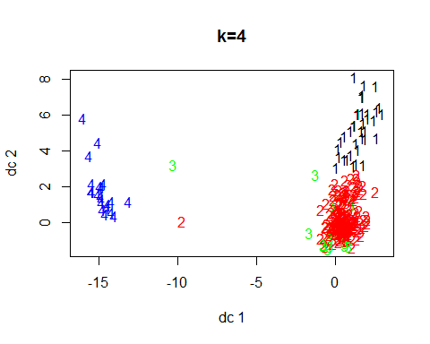

bakeryclusterwe4$withinss

## [1] 150.92000 613.07763 49.10000 57.96154

bakeryclusterwe4$tot.withinss

## [1] 871.0592

bakeryclusterwe4$betweenss

## [1] 124.8964

bakeryclusterwe4$totss

## [1] 995.9556

set.seed(123)  
bakeryclusterwe5 <- kmeans(bakeryweekend, centers=5)   
bakeryclusterwe5$size

## [1] 51 175 19 26 44

plotcluster(bakeryweekend, bakeryclusterwe5$cluster, main="k = 5")

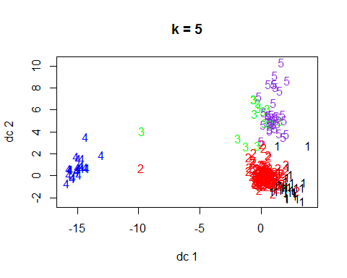

bakeryclusterwe5$withinss

## [1] 142.19608 481.34857 44.21053 57.96154 119.45455

bakeryclusterwe5$tot.withinss

## [1] 845.1713

bakeryclusterwe5$betweenss

## [1] 150.7843

bakeryclusterwe5$totss

## [1] 995.9556

set.seed(123)  
bakeryclusterwe6 <- kmeans(bakeryweekend, centers=6)   
bakeryclusterwe6$size

## [1] 41 166 19 24 39 26

plotcluster(bakeryweekend, bakeryclusterwe6$cluster, main="k = 6")

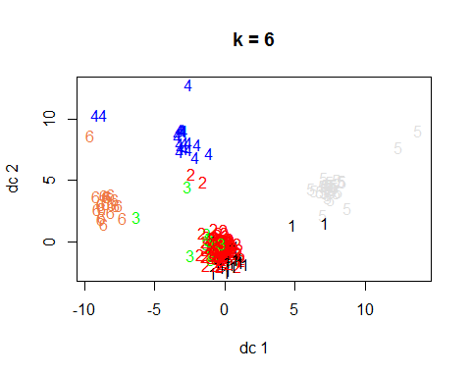

bakeryclusterwe6$withinss

## [1] 103.46341 443.65060 44.21053 49.20833 102.71795 67.26923

bakeryclusterwe6$tot.withinss

## [1] 810.5201

bakeryclusterwe6$betweenss

## [1] 185.4355

bakeryclusterwe6$totss

## [1] 995.9556

set.seed(123)  
bakeryclusterwe7 <- kmeans(bakeryweekend, centers=7)   
bakeryclusterwe7$size

## [1] 28 162 18 25 38 25 19

plotcluster(bakeryweekend, bakeryclusterwe7$cluster, main="k = 7")

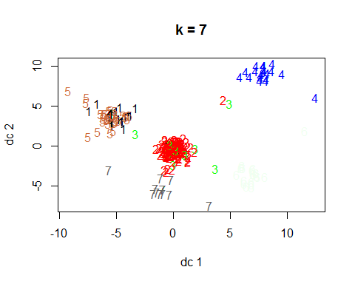

bakeryclusterwe7$withinss

## [1] 67.10714 426.79630 41.00000 53.60000 96.63158 62.24000 18.42105

bakeryclusterwe7$tot.withinss

## [1] 765.7961

bakeryclusterwe7$betweenss

## [1] 230.1595

bakeryclusterwe7$totss

## [1] 995.9556

set.seed(123)  
bakeryclusterwe8 <- kmeans(bakeryweekend, centers=8)   
bakeryclusterwe8$size

## [1] 17 180 18 11 32 24 18 15

plotcluster(bakeryweekend, bakeryclusterwe8$cluster, main="k = 8")

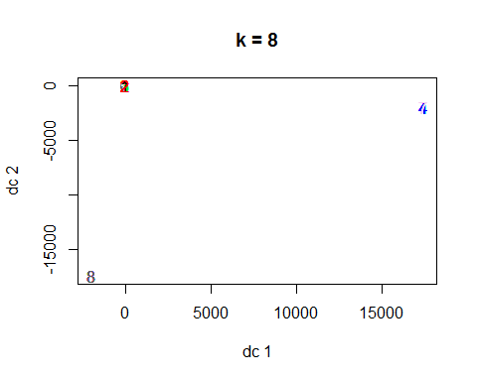

bakeryclusterwe8$withinss

## [1] 24.23529 483.96667 41.00000 40.00000 76.28125 55.29167 13.94444  
## [8] 38.00000

bakeryclusterwe8$tot.withinss

## [1] 772.7193

bakeryclusterwe8$betweenss

## [1] 223.2362

bakeryclusterwe8$totss

## [1] 995.9556

clusterswe4<- bakeryclusterwe4$tot.withinss/bakeryclusterwe4$totss  
clusterswe5<- bakeryclusterwe5$tot.withinss/bakeryclusterwe5$totss  
clusterswe6<- bakeryclusterwe6$tot.withinss/bakeryclusterwe6$totss  
clusterswe7<- bakeryclusterwe7$tot.withinss/bakeryclusterwe7$totss  
clusterswe8<- bakeryclusterwe8$tot.withinss/bakeryclusterwe8$totss  
totwithinss.metric <- c(clusterswe4, clusterswe5, clusterswe6, clusterswe7, clusterswe8)  
print(totwithinss.metric)

## [1] 0.8745964 0.8486034 0.8138115 0.7689059 0.7758572

clusterswe4<- bakeryclusterwe4$betweenss/bakeryclusterwe4$totss  
clusterswe5<- bakeryclusterwe5$betweenss/bakeryclusterwe5$totss  
clusterswe6<- bakeryclusterwe6$betweenss/bakeryclusterwe6$totss  
clusterswe7<- bakeryclusterwe7$betweenss/bakeryclusterwe7$totss  
clusterswe8<- bakeryclusterwe8$betweenss/bakeryclusterwe8$totss  
betweenss.metric <- c(clusterswe4, clusterswe5, clusterswe6, clusterswe7, clusterswe8)  
print(betweenss.metric) #Look for a ratio that is closer to 1.

## [1] 0.1254036 0.1513966 0.1861885 0.2310941 0.2241428

#WithinSS  
wss <- (nrow(bakeryweekend)-1)*sum(apply(bakeryweekend,2,var))  
for (i in 1:10) wss[i] <- sum(kmeans(bakeryweekend,centers=i)$withinss)  
plot(1:10, wss, type="b", xlab="Number of Clusters",  
 ylab="Within Sum of Squares", main = "Number of Clusters (k) versus Cluster Cohesiveness")

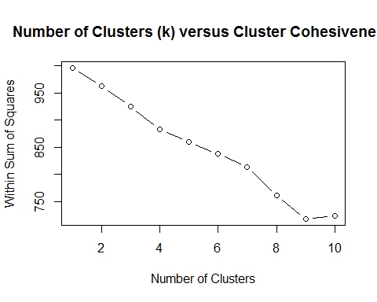

#BetweenSS  
wss <- (nrow(bakeryweekend)-1)*sum(apply(bakeryweekend,2,var))  
for (i in 1:10) wss[i] <- sum(kmeans(bakeryweekend,centers=i)$betweenss)  
plot(1:10, wss, type="b", xlab="Number of Clusters",  
 ylab="Between Group Sum of Squares", main = "Number of Clusters (k) versus Cluster Distinctiveness")

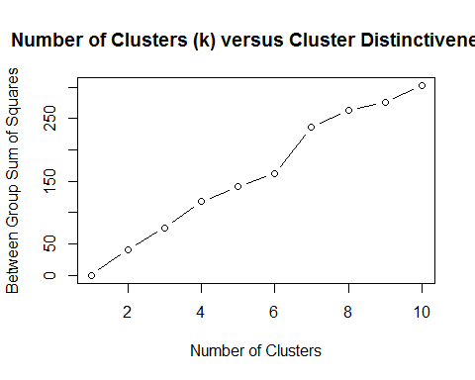

library(clusterSim)

## Warning: package 'clusterSim' was built under R version 3.3.3

## Loading required package: cluster

## Loading required package: MASS

##   
## This is package 'modeest' written by P. PONCET.  
## For a complete list of functions, use 'library(help = "modeest")' or 'help.start()'.

#?index.G1 #read the ../doc/indexG1_details.pdf  
  
a<-index.G1(bakeryweekend, bakeryclusterwe4$cluster, centrotypes = "centroids")   
b<-index.G1(bakeryweekend, bakeryclusterwe5$cluster, centrotypes = "centroids")  
c<-index.G1(bakeryweekend, bakeryclusterwe6$cluster, centrotypes = "centroids")  
d<-index.G1(bakeryweekend, bakeryclusterwe7$cluster, centrotypes = "centroids")  
e<-index.G1(bakeryweekend, bakeryclusterwe8$cluster, centrotypes = "centroids")  
pseudoF<-c(a,b,c,d,e)  
pseudoF

## [1] 14.86419 13.82653 14.13896 15.42820 12.67019

bakeryclusterwe4$size

## [1] 50 219 20 26

Clusterswe_4<-data.frame(bakeryclusterwe4$centers)  
Clusterswe_4<-data.frame(t(bakeryclusterwe4$centers))   
  
bakeryclusterwe5$size

## [1] 51 175 19 26 44

Clusterswe_5<-data.frame(bakeryclusterwe5$centers)  
Clusterswe_5<-data.frame(t(bakeryclusterwe5$centers))   
  
bakeryclusterwe6$size

## [1] 41 166 19 24 39 26

Clusterswe_6<-data.frame(bakeryclusterwe6$centers)  
Clusterswe_6<-data.frame(t(bakeryclusterwe6$centers))   
  
bakeryclusterwe7$size

## [1] 28 162 18 25 38 25 19

Clusterswe_7<-data.frame(bakeryclusterwe7$centers)  
Clusterswe_7<-data.frame(t(bakeryclusterwe7$centers))   
  
bakeryclusterwe8$size

## [1] 17 180 18 11 32 24 18 15

Clusterswe_8<-data.frame(bakeryclusterwe8$centers)  
Clusterswe_8<-data.frame(t(bakeryclusterwe8$centers))   
  
bakeryweekend$cluster <- bakeryclusterwe7$cluster  
aggregate(data = bakeryweekend, Weekend ~ cluster, mean)

## cluster Weekend  
## 1 1 1  
## 2 2 1  
## 3 3 1  
## 4 4 1  
## 5 5 1  
## 6 6 1  
## 7 7 1